**ROYAL GOVERNMENT OF BHUTAN**

**SANGBAY GEWOG ADMINISTRATION**

**HAA**



**TENDER DOCUMENT**

**FOR**

**CONSTRUCTION OF MEETING HALL**

**AT**

**SANGBAY GEWOG.**

INVITATION FOR BID

(IFB)

ROYAL GOVERNMENT OF BHUTAN

INVITATIONS FOR BIDS (IFB)

Date: 5th April 2019

Bid No.: DAH/ES-37/002

1. The **Sangbay Gewog Administration, Haa** invites bids for **the construction of** **meeting hall at Sangbay Gewog**.

2. Bidding documents (and additional copies) may be down loaded from the Dzongkhag web site from **8th April 2019 till 8th May 2019.**

3. Bids must be accompanied by a bid security of **Nu. 76,000.00** drawn in favour of **Dzongkhag Thrizin, Sangbay Gewog Administration, Haa.** Bid security will have to be in any one of the forms as specified in the bidding document and shall have to be valid for 30 days beyond the validity of the bid.

4. Bids must be delivered to **Gewog Engineer, Dzongkhag Engineering Office** on or before **10:00 hours** on **9th May 2019** and will be opened on the same day at **14:30 hours**, in **Dzongkhag Thrizin’s Office** in the presence of the bidders who wish to attend.

INVITATIONS FOR BIDS (IFB) 3

Section 1: Instructions to Bidder (ITB) 6

A. General 6

1. Scope of Tender 6

2. Corrupt Fraudulent Collusive or Coercive Practices 6

3. Eligible Bidders 7

4. Site Visit 7

B. Content of Bidding Document 7

5. Contents of Bidding Documents 7

6. Clarification of Bidding Documents 8

7. Amendment of Bidding Documents 8

C. Preparation of Bids 8

8. One Bid per Bidder 8

9. Bid Preparation Costs 8

10. Language of Bid 8

11. Documents comprising the Bid 8

13. Alternative Bid 9

14. Bid Price and Discount 9

15 Currencies of Bid and Payment 9

16 Documents comprising the Technical Proposal 9

17 Documents establishing the Qualification of the Bidder 9

18 Bid Validity 9

20 Format and Signing of Bid 10

D. Submission and Opening of Bids 10

21 Sealing and Marking of Bids 10

22 Bid Submission Deadline 10

23 Late Bids 11

24 Modification, Substitution or Withdrawal of Bids 11

25 Bid Opening 11

26 Confidentiality 11

27 Clarification 11

28 Bidder: Contacting the Employer 12

29 Determination of Responsiveness 12

30 Non Conformities, Errors and Omissions 12

31 Evaluation and Comparison of Tenders 12

32. Employer’s Right to Accept or Reject any or all 13

F. Contract Award 13

33. Award Criteria 13

34. Notification of Award 13

Section 2 - Bidding Data Sheet 13

A. General 13

B. Bidding Documents 14

C. Preparation of Bids 14

D. Submission and Opening of Bids 14

F. Award of Contract 15

Section 3 – Evaluation and Qualification Criteria 15

Section 4: Forms of Bid, & Qualification Information 15

Bank Guarantee for Bid Security 20

Section 5. General Conditions of Contract 21

1. Definitions 21

2. Interpretation & Documents forming the Contract 21

3. Corrupt, Fraudulent, Collusive or Coercive Practices 22

4. Governing Language and Law 23

5. Engineer’s Decision 23

6. Delegation 23

7. Communications and Notices 23

8. Sub- Contracting 23

9. Contractor’s Personnel 23

10. Welfare of Labourers & Child Labour 23

11. Safety, Security and Protection of the Environment 24

12. Access to the Site 24

13. Documents, Information. 24

14. Property 24

15. Insurance 24

16. Possession of the Site 24

17. Commencement of Works 24

18. Completion of Works 24

19. Programme of Works 24

20. Early Warning 25

21. Compensation Events 25

22. Non-Scheduled Items of Works 25

23. Schedule of Works 25

24. Payment Certificates 25

25. Payments and Currency 25

26. Retention 26

27. Liquidated Damages 26

28. Performance Security 26

29. Price Adjustment 26

30. Completion 26

31. Correction of Defects 26

32. Taking Over 26

33. Final Account 26

34. Termination 27

35. Payment upon Termination 27

36. Release from Performance 28

37. Force Majeure 28

38. Settlement of Disputes 28

38.1 The Employer and the Contractor shall use their best efforts to settle amicably all disputes arising out of or in connection with this Contract or its interpretation. 28

38.2 Any dispute between the parties to the Contract that may not be settled amicably will be referred to Arbitration at the initiative of either of the parties. 28

Section 6. Special Conditions of Contract 29

Section 7 – Contract Forms 31

Form-1 32

Form-2 33

Contract Agreement 33

Form-3 34

Bank Guarantee for Performance Security 34

Bank Guarantee for mobilisation advance 35

|  |  |
| --- | --- |
| Section 1: Instructions to Bidder (ITB) | |
| A. General | |
| Scope of Tender | 1. The Employer, as **indicated in the BDS** issues this Bidding Document for the procurement of Works as specified in Section 6 (Employer’s requirement): The name, identification and identification of this bidding are **provided in the BDS.** 2. The successful Bidder will be required to complete the Works within the Time for Completion stated in the Special Conditions of Contract (SCC). 3. Throughout this Bidding Documents;    1. The term “in writing means communicated in written form with proof of receipt;    2. If the context so requires, singular means plural and vice versa; and    3. “day” means calendar day. |
| Corrupt Fraudulent Collusive or Coercive Practices | * 1. The Royal Government of Bhutan requires that Employers and the Bidders shall observe the highest standard of ethics during the implementation of procurement proceedings and the execution of Contracts under public funds.   2. In pursuance of this requirement, the Employer shall  1. exclude the bidder from participation in the procurement proceeding concerned or reject a proposal for award; and 2. declare a bidder ineligible, either indefinitely or for a stated period of time, from participation in procurement proceedings under public funds;   2.3 If it, at any time, determines that the bidder has engaged in corrupt, fraudulent, collusive or coercive practices in competing for, or in executing, a Contract under the public funds.   * 1. The Government defines, for the purposes of this provision, the terms set forth below as follows :   *a) “****corrupt practice****”[1]* is the offering, giving, receiving or soliciting, directly or indirectly, of anything of value to influence improperly the actions of another party;  *b) “****fraudulent practice****”[2]* is any intentional act or omission including misrepresentation, that knowingly or recklessly misleads, or attempts to mislead, a party to obtain a financial or other benefits or to avoid an obligation;   * 1. *“****collusive practice****”[3]* is an arrangement between two or more parties designed to achieve an improper purpose, including to influence improperly the actions of another party;   *d) “****coercive practice****”[4]*is impairing *or* harming or threatening to impair or harm, directly or indirectly, any party or the property of the party to influence improperly the actions of a party.  2.5 The bidder shall be aware of the provisions on fraud and corruption stated in GCC Clause 3 and GCC Sub-Clause 34.2(d).  2.6 The RGoB requires that the Employer’s personnel have an equal obligation not to solicit, ask for and/or use coercive methods to obtain personal benefits in connection with the said proceedings. |
| Eligible Bidders | * 1. Bidders of the categories **specified in the BDS**are eligible to participate in this bidding process.   2. The Employer shall invite Bids using the Open Tendering Method (National Competitive Bidding) or limited tender as applicable.   3. The bidder shall meet the qualification requirement stated in the BDS |
| Site Visit | * 1. The Bidders, at their own responsibility and risk, is encouraged to visit and examine the Site and obtain all information that may be necessary for preparing the bid and entering into a Contract for performance of the Works**.** The costs of visiting the Site shall be at the bidder’s own expense. |
| B. Content of Bidding Document | |
| Contents of Bidding Documents | * 1. The sections comprising the Bidding Document are listed below and should be read in conjunction with any Amendment issued in accordance with ITB Clause 7:   **PART 1 Bidding Procedures**   * + - Section 1: Instructions to Bidders (ITB)     - Section 2: Bidding Data Sheet (BDS)     - Section 3: Evaluation and Qualification Criteria     - Section 4: Bidding forms     - Section 5: General Conditions of Contract (GCC)     - Section 6: Special Conditions of Contract (SCC)     - Section 7: Contract Forms     - Section 8: Bill of Quantities & Specifications     - Section 9: Drawings   1. The Employer is not responsible for the completeness of the Bidding Document and their Addenda, if they were not obtained directly from the source stated by the Employer in the Invitation for Bids.   5.3 The Bidder is expected to examine all instructions, forms terms, and specifications in the Bidding Documents. Failure to furnish all information or documentation required by the Bidding Documents may result in the rejection of the bid. |
| Clarification of Bidding Documents | * 1. A prospective Bidder requiring any clarification of the Bidding Document shall contact the Employer in writingat the Employer’s address **indicated in the BDS**. |
| Amendment of Bidding Documents | * 1. At any time prior to the deadline for submission of Bid, the Employer may amend the Bidding Document by issuing addenda and extend the deadline for the submission of bids at its discretion. Any amendment issued shall become an integral part of the Bidding Document and shall be communicated in writing to all those who have purchased the Bidding Document. |
| C. Preparation of Bids | |
| One Bid per Bidder | * 1. A Bidder shall submit only one (1) Bid. A Bidder who submits or participates in more than one (1) Bid shall cause all the proposals with the Bidder’s participation to be disqualified. |
| Bid Preparation Costs | * 1. The Bidder shall bear all costs associated with the preparation and submission of its Bids, and the Employer shall in no case be responsible or liable for those costs, regardless of the conduct or outcome of the Bidding process. |
| Language of Bid | * 1. All documents relating to the Bid shall be in the language specified in the BDS. |
| Documents comprising the Bid | 11.1 The original and copy(ies) of Bid submitted by the Bidder shall comprise the following:  (a) The Bid form (in the format indicated in Section IV – Forms of Bid, Qualification Information, Letter of Acceptance, and Contract);  (b) License and certificate  (c) Bid Security in accordance with Clause 19;  (d) Priced Bill of Quantities;  (e) and any other materials required to be completed and submitted by Bidders, as specified in the BDS.  11.2 The Instruction to Bidders, Bidding Data Sheet, General Conditions of Contract, Special Conditions of Contract, Specifications and drawings are for the information of the bidders and is not required to be submitted by the bidder, |
| 12 Letter of Bid and Schedule | 1. The letter of Bid, Schedules, and all documents listed under Clause 11, shall be prepared using the relevant forms in Section 4 (Bidding Forms), if so provided in BDS. The forms must be completed without any alterations to the text, and no substitutes shall be accepted. All blank spaces shall be filled in with the information requested. |
| Alternative Bid | * + - 1. Alternative Bid shall not be considered in small works. |
| Bid Price and Discount | * 1. The prices and discounts quoted by the Bidder in the Letter of Bid and in the Schedules shall confirm to the requirements specified below;   14.2 The bidder shall submit a bid for the whole of the works described in ITB 1.1 by filling in prices for all items of the Works, as identified in Section 4, Bidding Forms. In case of admeasurements contracts, the Bidder shall fill in rates and prices for all items of the Works described in the Bill of Quantities. Items against which no rate or price is entered by the Bidder will not be paid for by the Employer when executed and shall be deemed covered by the rates for other items and prices in the Bill of Quantities.   * 1. The Bid price shall take into account the cost of materials, transportation, labour, taxes, levies, overheads and profit and any other cost. The Bid price shall be fixed for the duration of performance of the Contract and shall not be subject to any adjustment on any account. The Bid price shall be applicable for the whole works described in the Drawings, Specifications and Schedule of Works. |
| Currencies of Bid and Payment | * 1. All prices shall be quoted in Bhutanese Ngultrum (BTN) and shall be paid in BTN. |
| Documents comprising the Technical Proposal | 16.1 The bidder shall furnish a work plan in simple bar chart and other information if provided in BDS, to demonstrate the adequacy of the Bidders’ proposal to meet the work requirements and the completion time. |
| Documents establishing the Qualification of the Bidder | * 1. To establish its qualification to perform the Contract in accordance with Section 3 (Evaluation and Qualification Criteria) the Bidder shall provide the information requested in the corresponding information sheets included in Section 4 (Bidding Forms) |
| Bid Validity | * 1. Bids shall remain valid for the period **specified in the BDS**. Any Bids which does not meet the validity requirement as per the BDS shall be rejected by the Employer as non-responsive. |
| 1. Bid Security | * 1. The Bidder shall at their option furnish, as part of the Bid, a Bid Security as **specified in the BDS** issued by any reputed Financial Institutions in Bhutan and shall be valid thirty (30) days beyond the Bid validity period.  1. Unconditional Bank Guarantee; 2. A demand Draft; or 3. Cash Warrant    1. In exceptional circumstances, prior to the expiration of the Bid validity period, the Employer may solicit the Bidder’s consent to an extension of the Bid validity period. The request and responses shall be made in writing. The validity of Bid Security shall be suitably extended promptly.   19.3 The Bid Security may be forfeited:  (a) if the Bidder withdraws the Bid after Bid opening during the period of Bid validity. Further the bidder may be excluded from future participation for a period of two years.  (b) if the Bidder does not accept the correction of the Bid price, pursuant to clause 31; or  (c) in the case of a successful Bidder, if the Bidder fails within the specified time limit to sign the Agreement; or furnish the required Performance Security. |
| Format and Signing of Bid | * 1. The Bidder shall prepare one (1) original of the documents comprising the Bid as described in ITB Clause 11 and clearly mark it “ORIGINAL.” In addition, the Bidder shall prepare the number of copies of the Bid, as specified in the BDS and clearly mark each of them “COPY.” In the event of any discrepancy between the original and the copies, the original shall prevail.   2. The original and each copy of the Bid shall be typed or written in indelible ink and shall be signed by the person duly authorized to sign on behalf of the Bidder.   3. Any interlineations, erasures, or overwriting shall be valid only if they are signed or initialled by the person(s) signing the Bid. |
| D. Submission and Opening of Bids | |
| Sealing and Marking of Bids | * 1. The Bidder shall enclose the original in one (1) envelope and all the copies of the bid in another envelope, duly marking the envelopes as “ORIGINAL” and “COPY.” These two (2) envelopes shall then be enclosed in one (1) single outer envelope.   2. The inner envelopes shall:  1. Be signed across the seals by the person authorised to sign the Bid on behalf of the Bidder; 2. Be marked “ORIGINAL” and “ COPY” and 3. Bear the name and address of the Bidder.   21.3 The outer envelope shall;  (a) Be signed across the seals by the person authorised to sign the Bid on behalf of the Bidder;   * 1. be addressed to the Employer at the address specified in the BDS; bear a statement “DO NOT OPEN BEFORE.......” the time and date for Bid opening as specified in the BDS.   2. If all or any envelopes are not sealed and marked as required by ITB Sub-Clause 21, the Employer **shall not reject the bids but assume no responsibility for the misplacement or premature opening of the Bid**. |
| Bid Submission Deadline | * 1. Bids must be received by the Employer at the address and no later than the date and time **specified in the BDS.**   22.2 Bids may be hand delivered, posted by registered mail or sent by courier.   * 1. The Employer may, at its discretion, extend the deadline for the submission of Bids by amending the Bidding Document in accordance with ITB Clause 7, in which case all rights and obligations of the Employer and Bidders previously subject to the deadline shall thereafter be subject to the new deadline as extended. |
| Late Bids | * 1. Late bids shall not be considered and shall be returned unopened |
| Modification, Substitution or Withdrawal of Bids | * 1. A Bidder may modify, substitute or withdraw their Bids after it has been submitted by sending a written notice before the deadline for submission of Bids. |
| Bid Opening | * 1. The Employer shall open the Bids in the presence of the bidders who is attending the bid opening, including modifications or substitutions made pursuant to ITB Clause 24. Bidders or their representatives shall be allowed to attend and witness the bid opening and shall sign a register evidencing their attendance.   2. The name of the Bidder, Bid modifications, substitutions or withdrawals, total amount of each Bid, number of corrections, discounts, and the presence or absence of requisite Bid Security, and such other details as the Employer, at its discretion, may consider appropriate, shall be read out aloud and recorded.   3. The Employer shall prepare minutes of the Bid opening. The minutes shall include, as a minimum, the name of the Bidders and whether there has been a withdrawal, substitution or modification; the Bid Price including any discounts and the presence or absence of a Bid Security, if one was required.   4. Bids not opened and read out at the Bid opening shall not be considered, irrespective of the circumstances, and shall be returned unopened to the Bidder.   5. Bids shall be rejected at the Bid opening only on the following grounds;  1. If the bid form is not complete and signed 2. Non-signing of BoQ; and 3. Insufficient amount of Bid Security and validity |
| **E. Tender Opening and Evaluation** | |
| Confidentiality | * 1. After the opening of Bids, information relating to the examination, clarification, and evaluation of Bids and recommendations for award shall not be disclosed to Bidders or other persons not officially concerned with the evaluation process until after the award of the Contract is announced. |
| Clarification | * 1. The Employer may ask Bidders for clarification of their Bids in order to facilitate the examination and evaluation of Bids. The request for clarification and the response shall be in writing, and any changes in the prices or substance of the Bid shall not be sought, offered or permitted, except to confirm the correction of arithmetical errors discovered by the Employer in the evaluation of the Bids, in accordance with ITB Clause 31. |
| Bidder: Contacting the Employer | * 1. Following the opening of Bids and until the Contract is signed no Bidder shall make any unsolicited communication to the Employer or try in any way to influence the Employer’s examination and evaluation of Bids which may result in the rejection of bids. If any Bidder wishes to contact the Employer on any matter related to the Bidding process, it should do so in writing |
| Determination of Responsiveness | * 1. The Employer’s determination of a bid’s responsiveness is to be based on the contents of the Bid itself without recourse to extrinsic evidence.   2. A substantially responsive Bid is one that conforms in all respects to the requirements of the Bidding Document without material deviation, reservation or omission. A material deviation, reservation or omission is one that:  1. affects in any substantial way the scope, quality, or performance of the Works specified in the Contract; or 2. limits in any substantial way, or is inconsistent with the Bid Document, the Employer’s rights or the Bidder’s obligations under the Contract; or   (c) if rectified would unfairly affect the competitive position of other Bidders presenting substantially responsive Bids.  29.3 If a Bid is not substantially responsive to the Bidding Document it shall be rejected by the Employer and shall not subsequently be made responsive by the Bidder by correction of the material deviation, reservation or omission.  29.4 There shall be no requirement as to the minimum number of responsive Bids. |
| Non Conformities, Errors and Omissions | * 1. The Employer may regard a Bid as responsive even if it contains minor deviations that do not materially alter or depart from the characteristics, terms, conditions and other requirement set forth in the Bidding Document or if it contains errors or oversights that are capable of being corrected without affecting the substance of the Bid. |
| Evaluation and Comparison of Tenders | * 1. The Employershall evaluate and compare only those Bids determined to be substantially responsive to the requirements of the Bidding Document. Substantially responsive Bids are those which fulfil the requirements of ITB Clauses 11 and 12.   2. The evaluation will take into account corrected Bid Price and discounts (if any).   3. The Employer will check substantially responsive Bids for any arithmetical errors. Where there is a discrepancy between the amounts in figures and words, the amount in words will govern. If a Bidder refuses to accept the correction, its Bids shall be rejected. The Employer shall correct arithmetical errors on the following basis:  1. if there is a discrepancy between the unit price and the line item total, the unit price shall prevail and the total price shall be corrected, unless in the opinion of the Employer there is an obvious misplacement of the decimal point in the unit price, in which case the total price, as quoted, shall govern and the unit price shall be corrected; and |
| 32. Employer’s Right to Accept or Reject any or all | * 1. The Employer reserves the right to accept any Bid, to annul the Bid proceedings, or to reject any or all Bids, at any time prior to Contract award, without thereby incurring any liability to Bidders, or any obligation to inform Bidders of the grounds for the Employer’s actions. |
| F. Contract Award | |
| 33. Award Criteria | 33.1 The Employer shall award the Contract to the Bidders whose offer is substantially responsive to the Bidding Document and that has been determined to be the lowest evaluated Bid, provided that the Bidder is determined to be qualified to perform the Contract satisfactorily |
| 34. Notification of Award | 34.1 Prior to the expiration of the period of Bid validity, the Employer shall notify the successful Bidder, in writing that its Bid has been accepted. Until a formal contract is prepared and executed, the Notification of Award shall constitute a binding Contract.  34.2 Within fifteen (15) working days of the receipt of the Notification of Award from the Employer, the successful Bidder shall furnish the Performance Security, in the amount specified in the BDS.  34.3 The proceeds of the performance security shall be payable to the Employer unconditionally upon first written demand as compensation for any loss resulting from the Contractor’s failure to complete its obligations under the Contract  34.4 Within fifteen (15) working days of receipt of the notification of award, the successful Bidder shall sign, date and return it to the Employer. |
| 35 complaints | 35.1 If there are any complaints both the parties shall submit the complaints as specified in BDS. The complaints if any shall be submitted within 10 working days from the date of notification of award. |

|  |  |
| --- | --- |
| Section 2 - Bidding Data Sheet | |
| *Instructions for completing the Bidding Data Sheet are provided, as needed, in the notes in italics mentioned for the relevant ITB Clauses* | |
| **ITB**  **Clause** | **Amendment of, and Supplements to, Clauses in the Instructions to Bidders** |
| A. General | |
| **ITB 1.1** | The Employer is  *Sangbay Gup, Gewog Administration Haa* |
| The Name and Identification of the Contract is/are  *Construction of meeting hall at Sangbay Gup Office*  The Works are *RRM foundationin in CM motar, superstructure,CGI sheet roofing with basic electrification and plumbing.* |
| **ITB 3.2** | **Option B: Open Tendering method**  All Bidders regardless of whether enlisted or not enlisted with the Dzongkhag may submit Bids provided they otherwise qualify. |
| **ITB 3.3** | The evaluation shall be based on the lowest price of the responsive bidder and the work will awarded to the lowest responsive bidder. *[Generally the selection is based on the lowest price. If there is a specific project need basic minimum technical qualification requirement should specified here]* |
| B. Bidding Documents | |
| **ITB 7.1** | For **clarification of Tenders purposes** only, the Employer’s address is:  Attention: ***Gewog Engineeer***  Address: Dzongkhag Thrizin, Sangbay Gewog Administration, Haa  Telephone:  Facsimile number:  Electronic mail address: Not applicable |
| C. Preparation of Bids | |
| **ITB 15.1** | The Bid validity period shall be [ 90 ] days.  *[normally be minimum of 90 days for Works of such a simple nature]* |
| **ITB 15.2** | A Bid Security of. *2%* of quoted amount will be required, in the form;   1. Unconditional Bank guarantee 2. Cash warrant; or 3. Demand draft |
| **ITB 16.1** | A simple bar chart is  *not required* |
| **ITB 19.1** | In addition to the original one copy shall be submitted. |
| D. Submission and Opening of Bids | |
| **ITB 17.2** | The inner and outer envelopes shall bear the following additional identification marks:  *Outer envelope shall bear*  Construction of meeting hall at Sangbay Gewog Office, Haa.  Inner envelope shall be mark   * + 1. Original     2. and other Copy |
| **ITB 17.2** | For **Bid submission purposes** only, the Employer’s address is:  Attention: Sangbay Gup, Gewog Administration, Haa  Address: Sangbay Gup, Gewog Administration, Haa  The deadline for the submission of Tenders is:  Time & Date 9/05/2019 before 10.00 AM |
| **ITB 21.1** | The Bid opening shall take place on the same day as the closing day of the bid submission at:  Date*:* 9/05/2019 *;* Time 2.30 PM |
| F. Award of Contract | |
| **ITB 34.2** | The amount of Performance Security shall be[*10%* percent of the Contract Price. |
| **ITB 35.1** | The name and address of the office where complaints to the Procuring Entity is to be submitted *Sangbay Gup, Gewog Administration, Haa.* |

# Section 3 – Evaluation and Qualification Criteria

This section contains all the criteria that the Employer shall use to evaluate bids and qualify Bidders if the bidding was not preceded by a prequalification exercise and post qualifications are applied. Procuring Agency may apply basic minimum technical qualification requirement (manpower and equipments) only if there is a project specific need.

* + - 1. **Evaluation**

1.1 Evaluation shall be done to determine the responsiveness and the award shall be made to the lowest evaluated bidder.

# Section 4: Forms of Bid, & Qualification Information

**Table of Standard Forms**

Standard Form: Form of Bid

Standard Form: Letter of Acceptance

Standard Form: Bid security Bank Guarantee

**Standard Form: Form of bid**

*Notes on Form of Bid:*

*The Bidder shall fill in and submit this bid form with the Bid. If Bidders do not fill in the Contract Price and does not sign this Bid form, the bids will be rejected..*

_______________________ [date]

To_________________________________________________________________________

Address_____________________________________________________________________

___________________________________________________________________________

___________________________________________________________________________

We offer to execute the contract for construction of “_________________” in accordance with the Conditions of Contract accompanying this Bid for the Contract Price of _______________________________________________________________ [*amount in figures*] ( ______________________________________________________________) [amount in words] ______________________________________ [*name of currency*].

The contract shall be paid in Ngultrums (Nu.)

This Bid and your written acceptance of it shall constitute a binding Contract between us. We understand that you are not bound to accept the lowest or any Bid you receive.

We hereby confirm that this Bid complies with the Bid validity and Bid Security required by the bidding documents and specified in the Bidding Data.

Authorized Signature: _________________________________________________________

Name and Title of Signatory: ___________________________________________________

Name of Bidder: _____________________________________________________________

Address: ___________________________________________________________________

**Standard Form: Qualification Information**

*Notes on Form of Qualification Information: The following information is to be filled in by bidders which will be used for purposes of evaluation*

**1. Individual bidders**

1.1 Constitution of legal status of Bidder [attach copy]

Place of registration: _____________________

Principal place of business: _____________________

Power of attorney of signatory of Bid [attach]

1.2 Qualifications and experience of key personnel proposed for administration and execution of the Contract. Refer BDS. The supporting documents such detailed CVs signed in original supported by certificates for qualification and experience.

|  |  |  |  |  |
| --- | --- | --- | --- | --- |
| **Position** | **Name** | **Qualification & year of experience (general)** | **Year of experience in proposed position** | **Remarks** |
| Supervisor |  |  |  |  |

**Standard Form: Letter of Acceptance**

[letterhead paper of the Employer]

*Notes on Standard Form of Letter of Acceptance*

*The Letter of Acceptance will be the basis for formation of the Contract as described in Clauses 31 and 32 of the Instructions to Bidders. This Standard Form of Letter of Acceptance should be filled in and sent to the successful Bidder only after evaluation of bids has been completed.*

_______________________ [date]

To: _________________________________________________________________________  
 [*name of the Contractor*]

____________________________________________________________________________  
 [*address of the Contractor*]

This is to notify that your Bid dated ______________________________________ for the execution of the contract for the construction of “______________-____________________” for the Contract Price ______________ [*amount in numbers*] _______________________________ [*amount in words*]_________________________ [*name of currency*], as corrected and modified in accordance with the Instructions to Bidders is hereby accepted by our Agency. The start date of the project is _________. The completion date for whole of the works shall be ____________.

You are hereby instructed to proceed with the execution of the said Works in accordance with the Contract documents.

Authorized Signature: _______________________________________________________

Name and Title of Signatory: _______________________________________________________

Name of Agency: _______________________________________________________

Attachment: Agreement

## Bank Guarantee for Bid Security

*[this is the format for the Bid Security to be issued by a financial institutions in Bhutan in accordance with ITB Clause 19]*

|  |  |
| --- | --- |
| Invitation for Bid No: | Date: |
| Bid Package No: |  |
| To:  **[**Name and address of Employer**]** |  |

**TENDER GUARANTEE No:**

We have been informed that *[name of Bidder]* (hereinafter called “the Bidder”) intends to submit to you its Bid dated *[date of bid]* (hereinafter called “the Tender”) for the execution of the Works of *[description of works]* under the above Invitation for Bids (hereinafter called “the IFB”).

Furthermore, we understand that, according to your conditions Bids must be supported by a Bid Guarantee.

At the request of the Bidder, we *[name of bank]* hereby irrevocably undertake to pay you, without cavil or argument, any sum or sums not exceeding in total an amount of Nu *[insert amount in figures and words]* upon receipt by us of your first written demand accompanied by a written statement that the Bidder is in breach of its obligation(s) under the Bid conditions, because the Bidder:

1. has withdrawn its Bids during the period of Bid validity specified by the Bidder in the Form of Bid; or
2. does not accept the correction of errors in accordance with the Instructions to Bidders ITB; or
3. having been notified of the acceptance of the Bid by the Employer during the period of Bid validity, (i) fails or refuses to furnish the performance security in accordance with the ITT, or (ii) fails or refuses to execute the Contract Form,

This guarantee will expire

1. if the Bidder is the successful Bidder, upon our receipt of a copy of the Performance Security and a copy of the Contract signed by the Bidder as issued by you; or
2. if the Bidder is not the successful Bidder, thirty days after the expiration of the Bidder’s Tender validity period, being *[date of expiration of the Tender].*

Consequently, we must receive at the above-mentioned office any demand for payment under this guarantee on or before that date.

|  |  |
| --- | --- |
| Signature | Signature |

|  |  |
| --- | --- |
| Section 5. General Conditions of Contract | |
| Definitions | * 1. The following words and expressions shall have the meaning hereby assigned to them. Boldface type is used to identify the defined terms:  1. **Completion Certificate** means the Certificate issued by the Employer as evidence that the Contractor has executed the Works in all respects as per drawing, specifications, and Conditions of Contract. 2. The **Completion Date** is the date of completion of the Works as certified by the Engineer, in accordance with GCC Clause 18. 3. **Contract** means the Agreement entered into between the Employer and the Contractor to execute, complete and maintain the Works. 4. **Contractor** means the person or corporate body whose Tender to carry out the Works has been accepted by the Employer and is named as such in the SCC. 5. **Contract Price** is the price stated in the Letter of Acceptance and thereafter as adjusted in accordance with the provisions of the Contract.The **Contractor’s Bid** is the completed Bid Document including the priced offer submitted by the Contractor to the Employer. 6. **Days** mean calendar days. 7. A **Defect** is any part of the Works not completed in accordance with the Contract. 8. The**Employer** is the party named in the SCC who employs the Contractor to carry out the Works. 9. The **Engineer** is the person named in the SCC, who is responsible for supervising the execution of the works and administering the Contract. 10. The **Intended Completion Date** is the date specified in the SCC on which the Contractor shall complete the Works and may be revised if extension of time or an acceleration order is issued by the Engineer. 11. The **Site** is the area defined as such in the SCC. 12. The **Works** are what the Contract requires the Contractor to construct, install, and hand over to the Employer, as defined in the SCC. |
| Interpretation & Documents forming the Contract | 1. In interpreting the GCC, singular also means plural, male also means female or neuter, and the other way around. Headings in the GCC shall not be deemed part thereof or be taken into consideration in the interpretation or construance of the Contract. Words have their normal meaning under the language of the Contract unless specifically defined. |
| 1. The following documents forming the Contract shall be interpreted in the following order of priority: 2. the signed Contract Agreement. 3. the letter of Notification of Award. 4. the completed Bid form as submitted by the Bidder. 5. the Special Conditions of Contract. 6. the General Conditions of Contract. 7. Specifications 8. the Drawings. 9. any other document listed in the PCC as forming part of the Contract. |
| Corrupt, Fraudulent, Collusive or Coercive Practices | * 1. The Government requires that Employers, as well as Contractors shall observe the highest standard of ethics during the implementation of procurement proceedings and the execution of Contracts under public funds.   2. In pursuance of this requirement, the Employer shall      1. exclude the Contractor from participation in the procurement proceedings concerned or reject a proposal for award; and      2. declare a Contractor ineligible, either indefinitely or for a stated period of time, from participation in procurement proceedings under public fund;   4. 3.3 The Government defines, for the purposes of this provision, the terms set forth below as follows:  1. corrupt practice”[5] is the offering, giving, receiving or soliciting, directly or indirectly, of anything of value[6] to influence improperly the actions of another party; 2. “fraudulent practice”[7] is any intentional act or omission, including a misrepresentation, that knowingly or recklessly misleads, or attempts to mislead, a party to obtain a financial or other benefit or to avoid an obligation; 3. “collusive practice”[8] is an arrangement between two or more parties designed to achieve an improper purpose, including to influence improperly the actions of another party; and 4. “coercive practice”[9] is impairing or harming, or threatening to impair or harm, directly or indirectly, any party or the property of the party to influence improperly the actions of a party.   3.4 The Government requires that the Client’s personnel have an equal obligation not to solicit, ask for and/or use coercive methods to obtain personal benefits in connection with the said proceedings. |
| Governing Language and Law | * 1. The Contract as well as all correspondence and documents relating to the Contract exchanged by the Contractor and the Employer, shall be written in English unless otherwise stated in the SCC. The Contract shall be governed by and interpreted in accordance with the laws of the Kingdom of Bhutan. |
| Engineer’s Decision | * 1. Except where otherwise specifically stated in the SCC, the Engineer will decide Contractual matters between the Employer and the Contractor in the role as representative of the Employer. |
| Delegation | * 1. The Engineer may delegate any of his duties and responsibilities to his representative, after notifying the Contractor, and may cancel any delegation, without retroactivity, after notifying the Contractor. |
| Communications and Notices | 1. Communications between Parties pursuant to the Contract shall be in writing to the address specified in the SCC. A notice shall be effective when delivered or on the notice’s effective date, whichever is later. |
| Sub- Contracting | 1. The Contractor shall not be permitted to subcontract any part of the Works in whole or in part. |
| Contractor’s Personnel | 9.1 The Contractor shall employ the key personnel named in the Schedule of Key Personnel, as referred to in the SCC, to carry out the functions stated in the Schedule, or other personnel approved by the Engineer. |
| Welfare of Labourers & Child Labour | 1. The Contractor shall provide proper accommodation to his labourers and arrange proper water supply, conservancy and sanitation arrangements at the site in accordance with relevant regulations, rules and orders of the government. 2. The Contractor shall comply with the applicable minimum age, labour laws and requirements of (including applicable treaties which have been ratified by) the Government of Bhutan regarding hazardous forms of child labour. |
| Safety, Security and Protection of the Environment | * 1. The Contractor shall throughout the execution and completion of the Works and the remedying of any defects therein :      1. have full regard for the safety of all persons entitled to be upon the Site and keep the Site and the Works in an orderly state;      2. provide and maintain at the Contractors own cost all lights, guards, fencing, warning signs and watching for the protection of the Works or for the safety on-site; and      3. take all reasonable steps to protect the environment on and off the Site and to avoid damage or nuisance to persons or to property of the public or others resulting from pollution, noise or other causes arising as a consequence of the Contractors methods of operation. |
| Access to the Site | 1. The Contractor shall allow the Engineer and any person authorised by the Engineer access to the Site and to any place where work in connection with the Contract is being carried out or is intended to be carried out. |
| Documents, Information. | 1. The Contractor shall furnish to the Engineer all information, schedules, calculations and supporting documentation that may be requested of it. |
| Property | * 1. If the contract is terminated by the Employer because of the contractors default, then, the contractor shall not be allowed to remove any materials on the Site, Plant, and Temporary Works until the matter is amicably resolved. |
| Insurance | 1. The Contractor shall provide insurance as stated in the SCC    1. The Contractor shall deliver policies and certificates of insurance to the Engineer, for the Engineer’s approval, before the Start Date.    2. If the Contractor does not provide any of the policies and certificates required, the Employer may effect the insurance which the Contractor should have provided and recover the premiums the Employer has paid from payments otherwise due to the Contractor or, if no payment is due, the payment of the premiums shall be a debt due. |
| Possession of the Site | 1. The Employer shall give possession of the Site, or parts of the Site, to the Contractor on the date(s) specified in the SCC. |
| Commencement of Works | 1. The Contractor may commence execution of the Works on the Start Date, or other such date as specified in the SCC, and shall carry out the Works in an expeditious manner. 2. If the Contractor fails to commence the works within the above stated period, the Employer may, at his sole discretion, terminate the Contract and forfeit the Performance Security, if any. |
| Completion of Works | 1. The Contractor shall complete the Works within the number of days stated in the SCC from the date of commencing the Works on the Site. |
| Programme of Works | 1. Within the time stated in the SCC, the Contractor shall submit to the Engineer for approval a work program. The Contractor shall submit to the Engineer for approval an updated Programme at intervals no longer than the period stated in the SCC. |
| Early Warning | 1. The Contractor shall warn the Engineer at the earliest opportunity of specific likely future events or circumstances that may adversely affect the quality of the work, result in increase to the Contract Price or delay in the execution of the Works. |
| Compensation Events | 1. The following shall be Compensation Events:   (a) the Employer does not give access to the Site or part of the Site by the Site Possession Date stated in the SCC; and  (b) if the payment is delayed pursuant to Clause 25.1.  21.2 If a Compensation Event would prevent the work being completed before the Intended Completion Date, the Intended Completion Date shall be extended, as appropriate, by the Engineer. |
| Non-Scheduled Items of Works | 1. The Contractor shall be paid for non-scheduled items of works only when the Engineer approves such works and at the rates and in the manner stated in the SCC. |
| Schedule of Works | 1. The Schedule of Works will contain rates for all items for the construction including temporary works, installation, testing, and commissioning work to be done by the Contractor.    1. The Contractor shall be paid for the quantity of the work done at the rate in the Contract Agreement for each item.    2. The Contractor shall be entirely responsible for all taxes, duties, license fees, and other such levies imposed outside and inside Bhutan. |
| Payment Certificates | 1. The Contractor shall submit to the Engineer monthly statements of the estimated value of the work executed less the cumulative amount certified previously. The Engineer shall check the Contractor’s monthly statement and certify the amount to be paid to the Contractor. 2. The value of work executed shall be determined by the Engineer. 3. The value of work executed shall comprise the value of the quantities of the items in the Schedule of Works completed. 4. The value of work executed shall include the valuation of Variations, Certified Dayworks and Compensation Events. 5. The Engineer may exclude any item certified in previous certificates or reduce the proportion of any item previously certified in any certificate in the light of later information. |
| Payments and Currency | 1. The Employer shall pay the Contractor the amounts certified by the Engineer within thirty (30) days of the date of each certificate. 2. The Employer shall make Advance Payment (mobilization and secured advance) to the Contractor of the amounts and by the dates stated in the SCC against provision by the Contractor of an unconditional Bank Guarantee, (Form 4). 3. The Contractor is to use the advance payment only to pay for Equipment, Plant, Materials, and mobilisation expenses required specifically for the execution of the Contract. The Contractor shall demonstrate that the advance payment has been used in this way by submitting copies of invoices or other documents to the Employer. 4. The advance payment shall be repaid by deducting proportionate amounts from payments otherwise due to the Contractor, following the schedule of completed percentages of the Works on a payment basis. No account shall be taken of the advance payment or its repayment in assessing valuations of work done, variations, claims or any amount payable due to failure to complete the works. |
| Retention | 1. The Employer shall retain from each payment due to the Contractor the proportion stated in the SCC until the completion of the whole of the Works. 2. On completion of the whole of the Works, half the total amount retained shall be repaid to the Contractor, the remaining half when the Defects Liability Period has passed and the Engineer has certified that all Defects notified by the Engineer to the Contractor before the end of this period have been corrected. |
| Liquidated Damages | * 1. The Contractor shall pay liquidated damages to the Employer at the rate per day stated in the SCC for each day that the Completion Date is later than the Intended Completion date for the works or for any part thereof. |
| Performance Security | 1. Upon Notification of Award, a Performance Security shall be provided to the Employer in the amount and form stated in the Contract Forms (Form 3). The Performance Security shall be valid until a date thirty (30) days from the date of issue of the Certificate of Completion. |
| Price Adjustment | 1. The rates and prices in the bill of quantities are fixed for the duration of the Contract and not subject to price adjustment during the performance of the Contract. |
| Completion | 1. The Contractor shall request the Engineer to issue a Certificate of Completion of the Works, and the Engineer will do so upon deciding that the work is substantially completed. |
| Correction of Defects | 1. The Engineer shall give notice to the Contractor of any Defects before the end of the Defects Liability Period, which begins at Completion, and is defined in the SCC. The Defects Liability Period shall be extended for as long as the Defects remain to be corrected. 2. If the Contractor has not corrected a Defect within the time specified in the Engineer’s notice, the Engineer will assess the cost of having the Defect corrected, and the Contractor will pay this amount. |
| Taking Over | 1. The Employer shall take over the Site and the Works within seven (7) days of the Engineer issuing a Certificate of Completion. |
| Final Account | 1. The Contractor shall supply the Engineer a detailed account of the total amount that the Contractor considers payable under the Contract. The Engineer shall certify any final payment that is due to the Contractor within twenty-one (21) days of receiving the Contractor’s account if it is correct and complete. 2. The Employer shall effect payment of the final account within thirty (30) days from the date of certification by the Engineer. |
| Termination | 1. The Employer or the Contractor by giving thirty (30) days written notice of default to the other party, may terminate the Contract in whole or in part if the other party causes a fundamental breach of Contract. 2. Fundamental breaches of the Contract shall include, but shall not be limited to, the following:    1. the Contractor stops work for more than thirty (30) days when no stoppage of work is shown on the current Programme and the stoppage has not been authorised by the Engineer;    2. the Engineer gives notice that failure to correct a particular defect is a fundamental breach of Contract and the Contractor fails to correct it within a reasonable period of time determined by the Engineer;    3. the Contractor has delayed the completion of the Works by the number of days for which the maximum amount of Liquidated Damages can be paid;    4. the Contractor, in the judgment of the Employer, has engaged in corrupt or fraudulent practices, as defined in GCC Clause 3, in competing for or in executing the Contract; and    5. a payment certified by the Engineer is not paid to the Contractor by the Employer within sixty (60) days of the date of the Engineer’s certificate. 3. The Employer and the Contractor may at any time terminate the Contract by giving notice to the other party if either of the parties becomes bankrupt or otherwise insolvent. In such event, termination will be without compensation to any party provided that such termination will not prejudice or affect any right of action or remedy that has accrued or will accrue to the other party. 4. Notwithstanding the above, the Employer may terminate the Contract for convenience. 5. If the Contract is terminated, the Contractor is to stop work immediately, make the Site safe and secure and hand over the Site to the Employer as soon as reasonably possible. |
| Payment upon Termination | 1. If the Contract is terminated because of a fundamental breach of Contract by the Contractor, the Engineer shall issue a certificate for the value of the work done and Plant and Materials ordered less advance payments received up to the date of the issue of the certificate and less the percentage to apply to the value of the work not completed, as indicated in the SCC.*.* Additional Liquidated Damages shall not apply. If the total amount due to the Employer exceeds any payment due to the Contractor, the difference shall be a debt payable to the Employer. 2. If the Contract is terminated for the Employer’s convenience or because of a fundamental breach of Contract by the Employer, the Contractor shall be entitled to payments for completed works and the materials that have been brought to the site for the purpose of the works, but not used as certified by the Engineer after adjusting any payments received by the Contractor. |
| Release from Performance | 1. If the Contract is frustrated by the outbreak of war or by any other event entirely outside the control of either the Employer or the Contractor, the Engineer shall certify that the Contract has been frustrated. The Contractor shall make the Site safe and stop work as quickly as possible, after receiving this certificate. The Contractor shall be paid for all works carried out before stoppage of work and any work carried out afterwards to which a commitment was made. |
| Force Majeure | 37.1 For the purposes of this Contract, “Force Majeure” means an exceptional event or circumstance:   1. which is beyond a Party’s control, 2. which such Party could not reasonably have provided against before entering into the Contract, 3. which, having arisen, such Party could not reasonably have avoided or overcome, and   (d) which is not substantially attributable to the other Party.     * 1. Force Majeure may include, but is not limited to, exceptional events or circumstances of the kind listed below, so long as conditions (a) to (d) above are satisfied:      1. war, hostilities (whether war be declared or not), invasion, act of foreign enemies, 2. rebellion, terrorism, sabotage by persons other than the Contractor’s Personnel, revolution, insurrection, military or usurped power, or civil war, 3. riot, commotion, disorder, strike or lockout by persons other than the Contractor’s Personnel, 4. munitions of war, explosive materials, ionizing radiation or contamination by radio-activity, except as may be attributable to the Contractor’s use of such munitions, explosives, radiation or radio-activity, and 5. natural catastrophes such as earthquake, hurricane, typhoon or volcanic activity.   37.3 However, force majeure shall not include the following;   1. rainfall   ii. snowfall  iii. strikes in other countries  iv. non-availability of labourer and materials such as timbers, boulders, sand, and other materials  v. difficulty and risky terrain and remoteness of site. |
| Settlement of Disputes | The Employer and the Contractor shall use their best efforts to settle amicably all disputes arising out of or in connection with this Contract or its interpretation.Any dispute between the parties to the Contract that may not be settled amicably will be referred to Arbitration at the initiative of either of the parties.  * 1. The Arbitration shall be conducted in accordance with the Arbitration Rules of the Kingdom of Bhutan in force. |

|  |  |
| --- | --- |
| Section 6. Special Conditions of Contract | |
| *Instructions for completing the Special Conditions of Contract are provided, as needed, in the notes in italics mentioned for the relevant GCC Clauses.3* | |
| **Clause**  **Ref** | **Amendments of, and Supplements to, Clauses in the General Conditions of Contract** |
| **GCC 1.1(d)** | The Contractor is *Nil* |
| **GCC 1.1(i)** | The Employer is Dzongkhag Thrizin, *Sangbay Gewog Administration, Haa* |
| **GCC 1.1(j)** | The Engineer is *Rinzin Phurba, Sangbay Gewog Engineer.* |
| **GCC 1.1(k)** | The Intended Completion Date for the whole of the Works shall be *18 Months* |
| **GCC 1.1(l)** | The Site is located at *Sangbay Gewog office.* |
| **GCC 1.1(m)** | The Works are *RRM foundationin in CM motar, superstructure,CGI sheet roofing with basic electrification and plumbing.* |
| **GCC 2.2(i)** | The additional documents forming part of this Contract are: *Not required* |
| **GCC 4.1** | The Language governing the Contract shall be  *English* |
| **GCC 5.1** | The Engineer shall obtain specific approval of the Employer before taking any of the following actions:  *Variation, additional, substitute and change in design scope.* |
| **GCC 7.1** | The addresses for Communications shall be:  For the Employer:  *Sangbay Gup, Gewog Administration, Haa*  For the Contractor:  *Nill* |
| **GCC 9.1** | The Key Personnel of the Contractor are: *Not Applicable* |
| **GCC 15.1** | For insurance purposes the type of cover required shall be: The contractor shall be responsible for the insurance. |
| **GCC 16.1** | Possession of the site shall be within [ 10 ] days from the date of signing of the Contract. |
| **GCC 17.1** | Commencement of work shall be within [10 ] days from the date of handing over possession of the Site. |
| **GCC 18.1** | Completion of works shall be within [ 18 months ] from the date of commencing the works on the site. |
| **GCC 19.1**  **& 19.2** | The Contractor shall submit the first work plan 10 days after signing the Contract, and shall update the work plan every 4 weeks during the period of the Contract. |
| **GCC 22.1** | *[ Enter here the agreed rates for non-scheduled items of work if known, if not known then make the statement “The rates for non-scheduled items of works shall be determined by the Engineer”.* |
| **GCC 25.2** | An advance payment of *10* % of the Contract Price will be made to the Contractor upon production of Bank Guarantee. |
| **GCC 26.1** | The Retention shall be *10* % of the Contract Price. |
| **GCC 27.1** | The liquidated damages for the whole of the Works shall be *0.075 percent per day and the total amount is not to exceed 10 percent of the Contract Price.* |
| **GCC 31.1** | The Defects Liability Period shall be 12 months*.* |
| **GCC 35.1** | The percentage to apply to the value of the work not completed, representing the Employer’s additional cost for completing the Works, is *20% of the value of work not completed up to a maximum of 10% of the initial contract price* |
|  |  |

# 

# Section 7 – Contract Forms

This section contains forms which, once completed, will form part of the Contract. The forms for Performance Security and Advance Payment Security, when required, shall only be completed by the successful Bidder after Contract award.

**Contract Forms**

|  |  |
| --- | --- |
| Form | Title |
| Form -1 | Notification of Award |
| Form -2 | Contract Agreement |
| Form -3 | Bank Guarantee for Performance Security |
| Form -4 | Bank Guarantee for Advance Payment |

## Form-1

**Notification of Award**

|  |  |
| --- | --- |
| Contract No: | Date: |
| *To:*  *[name and address of Contractor]* |  |

This is to notify you that your Bid dated *[insert date]* for the execution of the Works for *[name of project / Contract]* for the Contract Price of Nu [*amount in figures and in words*],as corrected and modified in accordance with the Instructions to bidder is hereby accepted by *[name of the Employer].*

You are requested to proceed with the execution of the Works on the basis that this Notification of Award shall constitute the formation of a Contract, which shall become binding upon you furnishing a Performance Security within fourteen (14) days, in accordance with ITB Clause 32, and the signing the Contract Agreement within twenty-one (21) days, in accordance with ITB Clause 33.

We attach the Contract Agreement and Special Conditions of Contract for your perusal

and signature.

|  |  |
| --- | --- |
|  | Signed  Duly authorised to sign for and on behalf of  *[name of Procuring Entity]* |
|  | Date: |

## Form-2

## Contract Agreement

THIS AGREEMENT, made the [*day*] of [*month*] [*year*] between [*name and address of Employer*] (hereinafter called “the Employer”) of the one part and [*name and address of Contractor*] (hereinafter called “the Contractor”) of the other part.

WHEREAS, the Employer invited Tenders for certain Works, viz, [*brief description of the Works]* and has accepted a Tender by the Contractor for the execution of those works in the sum of Ngultrum [*insert amount in figures and words]*, hereinafter called “the Contract Price.

NOW THIS AGREEMENT WITNESSETH as follows:

1. In this Agreement, words and expressions shall have the same meanings as are respectively assigned to them in the General Conditions of Contract hereinafter referred to.
2. The documents forming the Contract shall be interpreted in the following order of priority:
3. The signed Contract Agreement;
4. The letter of Acceptance;
5. The completed Bid form as submitted by the Bidder;
6. The Special Conditions of Contract;
7. The General Conditions of Contract;
8. Specifications
9. The Drawings; and
10. Any other document listed in the SCC as forming part of the Contract..

3. In consideration of the payments to be made by the Employer to the Contractor as hereinafter mentioned, the Contractor hereby covenants with the Employer to execute and complete the Works and to remedy any defects therein in conformity in all respects with the provisions of the Contract.

4. The Employer hereby covenants to pay the Contractor in consideration of the execution and completion of the Works and the remedying of defects therein, the Contract Price or such other sum as may become payable under the provisions of the Contract at the times and in the manner prescribed by the Contract.

**IN WITNESS whereof the Parties thereto have caused this Agreement to be executed in accordance with the laws of Bhutan on the day month and year first before written.**

|  |  |  |
| --- | --- | --- |
|  | For the Employer | For the Contractor |
| Signature |  |  |
| Print Name |  |  |
| Title |  |  |
| In the presence of (Name) |  |  |
| Address |  |  |

## Form-3

## Bank Guarantee for Performance Security

*[this is the format for the Performance Security to be issued by any financial institute in Bhutan in accordance with* ***ITB*** *Clause 35]*

|  |  |
| --- | --- |
| Contract No: | Date: |
|  |  |
| To:  [Name and address of Employer] |  |

**PERFORMANCE GUARANTEE No:**

We have been informed that *[name of Contractor]* (hereinafter called “the Contractor”) has undertaken, pursuant to Contract No *[reference number of Contract]* dated *[date of Contract]* (hereinafter called “the Contract”), the execution of works *[description of works]* under the Contract.

Furthermore, we understand that, according to your conditions, Contracts must be supported by a performance guarantee.

At the request of the Contractor, we *[name of bank]* hereby irrevocably undertake to pay you, without cavil or argument, any sum or sums not exceeding in total an amount of Nu *[insert amount in figures and in words]* upon receipt by us of your first written demand accompanied by a written statement that the Contractor is in breach of its obligation(s) under the Contract conditions, without you needing to prove or show grounds or reasons for your demand of the sum specified therein.

This guarantee is valid until *[date of validity of guarantee]*, consequently, we must receive at the above-mentioned office any demand for payment under this guarantee on or before that date.

|  |  |
| --- | --- |
| Signature | Signature |

Form-4

## Bank Guarantee for mobilisation advance

*[this is the format for the Advance Payment Guarantee to be issued by a financial institutions in Bhutan in their letter pad in accordance with SCC Clause 25.2]*

|  |  |
| --- | --- |
| Contract No: | Date: |
|  |  |
| To:  [Name and address of Employer] |  |

**ADVANCE PAYMENT GUARANTEE No:**

We have been informed that *[name of Contractor]* (hereinafter called “the Contractor”) has undertaken, pursuant to Contract No *[reference number of Contract]* dated *[date of Contract]* (hereinafter called “the Contract”), the execution of works *[description of works]* under the Contract.

Furthermore, we understand that, according to your conditions, Advance Payments must be supported by a bank guarantee.

At the request of the Contractor, we *[name of bank]* hereby irrevocably undertake to pay you, without cavil or argument, any sum or sums not exceeding in total an amount of Nu. *[insert amount in figures and in words]* upon receipt by us of your first written demand accompanied by a written statement that the Contractor is in breach of its obligation(s) under the Contract conditions, without you needing to prove or show grounds or reasons for your demand of the sum specified therein.

We further agree that no change, addition or other modification of the terms of the Contract to be performed, or of any of the Contract documents which may be made between the Employer and the Contractor, shall in any way release us from any liability under this guarantee, and we hereby waive notice of any such change, addition or modification.

This guarantee is valid until *[date of validity of guarantee]*, consequently, we must receive at the above-mentioned office any demand for payment under this guarantee on or before that date.

|  |  |
| --- | --- |
| Signature | Signature |

**Section 8 Nill of Quantities (BoQ)**

|  |  |  |  |  |  |  |  |
| --- | --- | --- | --- | --- | --- | --- | --- |
| **Name of Project : Construction of meeting hall** | | |  | **Geog : Sangbay** | | |  |
|  |  |  |  |  | | |  |
| **Sl.No.** | **BSR ref.** | **Description of items(Specification)** | **Qty.** | **Unit** | **Rate** | **In words** | **Amount (Nu.)** |
|  |  | **CLEARING AND GRUBBING** |  |  |  |  |  |
| **1** | ##### | Clearing jungle including uprooting of vegetation & trees of girth < 300mm and disposal within 50m the site | 221 | Sq.m |  |  |  |
|  |  | **EARTH WORK** |  |  |  |  |  |
| 2 | ##### | Excavation in foundation trenches or drains not excedding 1.5 in width or area 10 sq.m on plan incl. dressing & ramming, disp. of surplus soil within 50m lead & 1.5m lift: Ordinary Soil | 80 | Cu.m |  |  |  |
|  |  | **STONE MASONRY** |  |  |  |  |  |
| 3 | ##### | Providing and laying hand packed stone soling or filling with stones . | 10 | Cu.m |  |  |  |
| 4 | ##### | Providing and laying in position plain cement concrete excluding the cost of centering and shuttering - All work upto plinth level. 1:3:6 (1 cement : 3 sand : 6 graded crushed rock 40 mm nominal size) | 7 | Cu.m |  |  |  |
|  |  | **STONE MASONRY** |  |  |  |  |  |
| 5 | ##### | Providing & laying Random Rubble Masonry with hard stone in found'n & plinth: In cement mortar 1:5 | 36 | Cu.m |  |  |  |
| 6 | ##### | Filling of trenches, sides of foundations etc in layers <200mm using selected excavated earth, ramming etc within lead 50m & lift 1.5m. | 24 | Cu.m |  |  |  |
|  |  | **DAMP-PROOFING** |  |  |  |  |  |
| 7 | ##### | Providing and laying damp-proof course with cement concrete 1:2:4, 12.5mm aggregate: 25mm thick | 30 | Sq.m |  |  |  |
|  |  | **REINFORCEMENT CEMENT** |  |  |  |  |  |
| 8 | ##### | Providing & laying R.C.C 1:2:4, 20mm aggregate in walls(any thickness) including attached pilasters buttresses, piers, abutments etc. up to floor five level excluding the cost of centering, shuttering and reinforcement. | 13 | Cu.m |  |  |  |
|  |  | **REINFORCEMENT CEMENT** |  |  |  |  |  |
| 9 | ##### | Providing & fixing, mild steel reinforcement (Fe250) for R.C.C work including cutting, bending, binding and placing in position complete | 1806 | Kg |  |  |  |
|  |  | **REINFORCEMENT CEMENT** |  |  |  |  |  |
| 10 | ##### | Providing & fixing centering and shuttering (formwork), including strutting, propping etc. and removal of formwork: Columns, pillars, post, struts etc. | 40 | Sq.m |  |  |  |
| 11 | ##### | Providing & fixing centering and shuttering (formwork), including strutting, propping etc. and removal of formwork: Lintels, beams, girders, bresummers, cantilevers etc. | 139 | Sq.m |  |  |  |
|  |  | **STONE MASONRY** |  |  |  |  |  |
| 12 | ##### | Providing & laying Coursed Rubble Masonry with hard stone in found'n & plinth: In cement mortar 1:5 | 45 | Cu.m |  |  |  |
| 13 | ##### | Extra, for C.R. masonry with hard stone in superstructure above plinth, below & including floor 2 level. | 45 | Cu.m |  |  |  |
| 14 | ##### | Providing & laying pointing on stone work with cement mortar 1:3: Flush pointing | 51 | Sq.m |  |  |  |
|  |  | **PLINTH PROTECTION & DRAINAGE** |  |  |  |  |  |
| 15 | ##### | Providing and laying 50mm thick plinth protection and grouted with fine sand mix incl. Well rammed, finishing the top smooth: With cement concrete 1:3:6, 20mm agg laid over 75mm thick layer of compacted gravel (40mm) | 68 | Sq.m |  |  |  |
| 16 | ##### | Constructing random rubble masonry open surface drain in cement mortar 1:6, including earth work in excavation, 100mm thick conc. base 1:5:10, 40mm aggregate 25mm thick cement concrete 1:2:4, 12mm aggregate for filling haunches, including 20mm cement plaster with a floating coat of neat cement, disposal of surplus earth. 150 X 200mm depth | 58 | mtr |  |  |  |
|  |  | **FLOORING** |  |  |  |  |  |
| 16 | ##### | Providing and laying hand packed stone soling or filling with stones . | 26 | Cu.m |  |  |  |
| 17 | ##### | Providing and laying in position plain cement concrete excluding the cost of centering and shuttering - All work upto plinth level. 1:2:4 (1 cement : 2 sand : 4 graded crushed rock 20 mm nominal size) | 17 | Cu.m |  |  |  |
| 18 | ##### | P&l cement concrete flooring 1:2:4, finished with floating coat of neat cement: 20mm river gravel, 40mm thick | 111 | Sq.m |  |  |  |
|  |  | **NAMPA** |  |  |  |  |  |
| 19 | ##### | Providing & fixing joist, including hoisting, applying wood preservative on unexposed surfaces: Mixed Conifer | 4 | Cu.m |  |  |  |
| 20 | ##### | P&f. Mixed Conifer Flooring including fixing with iron screws etc. complete, excluding the cost of frame: 25mm thick, half-lapped | 121 | Sq.m |  |  |  |
|  |  | **PLASTERING** |  |  |  |  |  |
| 21 | ##### | P&l. 12mm cement plaster: C.M 1:5 | 105 | Sq.m |  |  |  |
|  |  | **DOORS AND WINDOWS** |  |  |  |  |  |
| 22 | A/R | P&F, window compoments (W9) as per drawing details complete including glazed shutters, fittings, hinges complete. | 6 | L/s |  |  |  |
| 23 | A/R | P&F, window compoments (W1) as per drawing details complete including glazed shutters, fittings, hinges complete. | 2 | L/s |  |  |  |
| 24 | A/R | P&F, doors and windows compoments at main entrance as per drawing details complete including glazed shutters, fittings, hinges complete. | 1 | L/s |  |  |  |
| 25 | ##### | P&f. 75mm thick split bamboo wall incl. grooving frames, 20mm plaster cement mortar 1:5 both sides ( excl. cost of frame) | 4 | Sq.m |  |  |  |
| 26 | ##### | Providing , making & fixing wood work dressed in traditional cornices complete as per standard design in mixed conifer, including applying wood preservative on unexposed surfaces, excluding decorative painting ( Measurement to be taken along the corniceFor single-storied structure including phana | 14 | mtr |  |  |  |
| 27 | ##### | Providing , making & fixing wood work dressed in traditional cornices complete as per standard design in mixed conifer, including applying wood preservative on unexposed surfaces, excluding decorative painting ( Measurement to be taken along the corniceAt all other floor levels (excluding phana) | 20 | mtr |  |  |  |
|  |  | **ROOFING** |  |  |  |  |  |
| 28 | ##### | Steel work welded, in built up sections, trusses, frame-works incl. cutting, hoisting, fixing and appl. priming coat of red lead paint: In Tabular sections 80mm dia, 5mm thickness. | 9231 | kg. |  |  |  |
| 29 | ##### | Providing & fixing Eaves board(225x25mm) with moulding fitted & fixed with necessary screws:Mixed Conifer | 80 | mtr |  |  |  |
| 30 | ##### | Providing & fixing Pre Painted Steel Corrugated Roofing sheets, including bolts, hooks and nuts 8mm dia. with bitumen and G.I limpet washers filled with white lead for connection, excluding the cost of purlins, rafter and trusses- 25g (0.50mm) | 210 | Sq.m |  |  |  |
| 31 | ##### | Providing & fixing 600mm ridges or hips in Pre Painted Steel sheets, including bolts, hooks and nuts 8mm dia G.I limpet and bitumen washers for connection- 25g (0.50mm) | 38 | mtr |  |  |  |
| 32 | ##### | Providing and applying finishing coats, with :-Dry distemper, two coats on new work, incl. white priming coat | 117 | Sq.m |  |  |  |
| 33 | A/R | Providing, preparing and applying bhutanese traditional painting, Ding category for inside and outside cornices for whole building. | 1 | L/s |  |  |  |
| **A** |  | **Quoted Amount for civil work** | |  |  | **Nu.** |  |

|  |  |  |  |  |  |  |  |
| --- | --- | --- | --- | --- | --- | --- | --- |
| ***Name of Project: Electrification of Meeting Hall at Sangbaykha Geog*** | | |  | *Geog : Sangbaykha* | | | |
|  |  |  |  |  | | | |
| **Sl. No** | **BSR ref.** | **Description of items(Specification)** | **Qty.** | **Unit** | **Rate Figure** | **Rate Word** | **Amount** |
|  |  | **Wiring** |  |  |  |  |  |
| 1. | #### | Wiring for light, fans, call bell and 2 pin light socket outlet with 1.5 sq.mm 1.1kV grade, PVC insulated copper conductor cable in recessed HDPE pipe including connections, painting, testing and commissioning etc. as required-Short Point | 1.00 | Point |  |  |  |
| 2. | #### | Wiring for light, fans, call bell and 2 pin light socket outlet with 1.5 sq.mm 1.1kV grade, PVC insulated copper conductor cable in recessed HDPE pipe including connections, painting, testing and commissioning etc. as required-Medium Point | 5.00 | Point |  |  |  |
| 3. | #### | Wiring for light, fans, call bell and 2 pin light socket outlet with 1.5 sq.mm 1.1kV grade, PVC insulated copper conductor cable in recessed HDPE pipe including connections, painting, testing and commissioning etc. as required-Long Point | 20.00 | Point |  |  |  |
| 4. | #### | Wiring for 5/6 pin, 6/16 ampere plug point with 4 sq.mm 1.1kV grade, PVC insulated copper conductor cable in recessed HDPE pipe with providing and fixing 5/6 pin, 6/16 ampere socket outlet and switch including earthing the third pin, connections, painting, testing and commissioning etc. as required-Long Point | 6.00 | Point |  |  |  |
| 5. | #### | Wiring for lighting circuit with 1.1kV grade, PVC insulated copper conductor cable in recessed HDPE pipe including connections, painting, testing and commissioning etc. as required-2x2.5 sq.mm | 50.00 | mtr. |  |  |  |
|  |  | **Indoor Luminaries** |  |  |  |  |  |
| 6. | #### | Supplying & fixing of switch/socket on existing PVC/ wooden /metal/ moulded tough surface box with fibre sheet cover, round block, junction box (recessed or surface) including necessary cutting,connection testing etc. as required - **Batten holder** | 8 | Each |  |  |  |
| 7. | #### | Supplying & fixing of switch/socket on existing PVC/ wooden /metal/ moulded tough surface box with fibre sheet cover, round block, junction box (recessed or surface) including necessary cutting,connection testing etc. as required - **Angle Holder** | 3 | Each |  |  |  |
| 8. | MR | Supplying of prewired linear batten LED tube light**-LB-4F-36W(Set)** | 8.00 | Each |  |  |  |
|  |  | **LAMPS & LAMP SHADES** |  |  |  |  |  |
| 9. | #### | Supplying of LED lamps/Bulbs 240 volt AC - 12W (BC/ES) | 11.00 | Each |  |  |  |
|  |  | **FANS (Supply)** |  |  |  |  |  |
| 10. | #### | Supplying of ceiling fan 240 volt A.C 1400 rpm with all accessories such as down rod, sweep 3 Nos.,canopy 2 Nos., condenser and fan body etc. complete as- **1200mm sweep** | 7.00 | Each |  |  |  |
| 11. | #### | Supplying & fixing of socket/regulator on existing wooden board including necessary cutting, connection testing etc. as required - Dimmer/regulator | 7 | Each |  |  |  |
|  |  | **required** |  |  |  |  |  |
| 12. | #### | Supply of miniature circuit breaker (MCB) single pole, 230 volt A.C complete with all accessories suitable to fix on a din-bar etc. as required - 10A | 3.00 | Each |  |  |  |
| 13. | #### | Supply of miniature circuit breaker (MCB) single pole, 230 volt A.C complete with all accessories suitable to fix on a din-bar etc. as required - 16A | 7.00 | Each |  |  |  |
| 14. | #### | Supply of miniature circuit breaker (MCB) double pole, 230 volt A.C complete with all accessories suitable to fix on a din-bar etc. as required - 63A | 1.00 | Each |  |  |  |
|  |  | **Distribution Board (DB** |  |  |  |  |  |
| 15. | #### | Supplying of SPN distribution board (Din type) without door, 230V A.C complete with all accessories without MCB/isolator/RCCB outgoing or incoming etc. as required to accommodate on/in prefabricated MS surface/MS cubical control panel board including drilling holes, connection etc. as required-**12 Way** | 1.00 | Each |  |  |  |
| 16. | #### | Supplying of 2-core 1.1kV grade PVC insulated and sheathed Aluminium conductor armoured power cables- **16 Sq.mm** | 60.00 | mtr. |  |  |  |
| 17. | #### | Providing and fixing of earthing including all accessories, machinery enclosure, C.I cover plate having locking arrangement, watering pipe with excavation and refilling work including charcoal or coke and salt complete as required as per standard earthing drawing-With G.I earth plate 600x600x6mm | 1.00 | Each |  |  |  |
| 18. | ET0015 | Providing and laying earth connection from earth electrodes in 15mm dia G.I pipe from earth electrodes as required as per guidence of standard earthing drawing-**With 4.06mm dia (8SWG) G.I wire** | 15.00 | mtr. |  |  |  |
|  |  | **ERECTION/INSTALLATION (Luminiaries)** |  |  |  |  |  |
| 19. | #### | Erection of all indoor/outdoor surface type wall bracket (single or double)/ surface ceiling fittings GLS lamps/ bulk head GLS lamp / all types call bell / all type picture or mirror lighting luminiaries fittings with all accessories, fixing of lamp, testing etc. as required including connection with PVC insulated copper conductor-1 sq.mm single core cable 1.1 KV grade | 15.00 | Each |  |  |  |
|  |  | **Minature Circuit Breaker (MCB)** |  |  |  |  |  |
| 20. | #### | Installation, testing and commissioning of SPN/DP miniature circuit breaker DIN type complete with all accessories to accommodate on/in prefabricated MS surface /MS cubical control panel board including drilling holes, connections etc as required-6/10/16/20A | 10.00 | Each |  |  |  |
| 21. | #### | Installation, testing and commissioning of SPN/DP miniature circuit breaker/ isolator DIN type complete with all accessories to accommodate on/in prefabricated MS surface /MS cubical control panel board including drilling holes, connections etc as required -50/63A | 1.00 | Each |  |  |  |
|  |  | **Distribution Board** |  |  |  |  |  |
| 22. | #### | Installation, testing and commissioning of SPN distribution board (Din type) without door, 230V A.C complete with all accessories without MCB/isolator/RCCB outgoing or incoming etc. as required to accommodate on/in prefabricated MS surface/MS cubical control panel board including drilling holes, connection etc. as required-**12 Way** | 1.00 | Each |  |  |  |
|  |  | **POWER CABLE (Laying)** |  |  |  |  |  |
| 23. | #### | Laying of one number PVC insulated and sheathed power cable copper/aluminium,armoured/un-armoured 1.1KV single core to four core direct in the ground including excavation, sand cushing, protective covering and refilling the trenches etc. as required- Above 6sq.mm to 25sq.mm | 45.00 | mtr. |  |  |  |
|  |  | **Metering & Shuttering** |  |  |  |  |  |
| 24. |  | Providing and erection of Watt Hour Meter, 230V A.C complete with all accessories including meter security, energy security and meter connection etc. as required from the concerned BPCL |  |  |  |  |  |
|  | EM SP | 1-Phase Watt Hour Meter( Suitable Rating) | 1.00 | Lumpsum |  |  |  |
| 25. |  | Providing and erection of concealed wooden box with wire mesh to hold main switches including painting etc. as required as per site engineer's instruction |  |  |  |  |  |
|  |  | 600x450x230mm deep | 1.00 | Lumpsum |  |  |  |
| **B** |  | **Quoted amount for electrical work** | | |  |  |  |
| **C** |  | **Over all quoted amount (A+B)** | | |  |  |  |
|  |  | | | | | |  |

**Section 9. Drawings**

|  |
| --- |
| **Notes on Drawings**  Insert here a list of Drawings. The actual Drawings, including site plans, should be attached to this section or annexed in a separate folder. The Drawings shall be dated, numbered and show the revision number. |

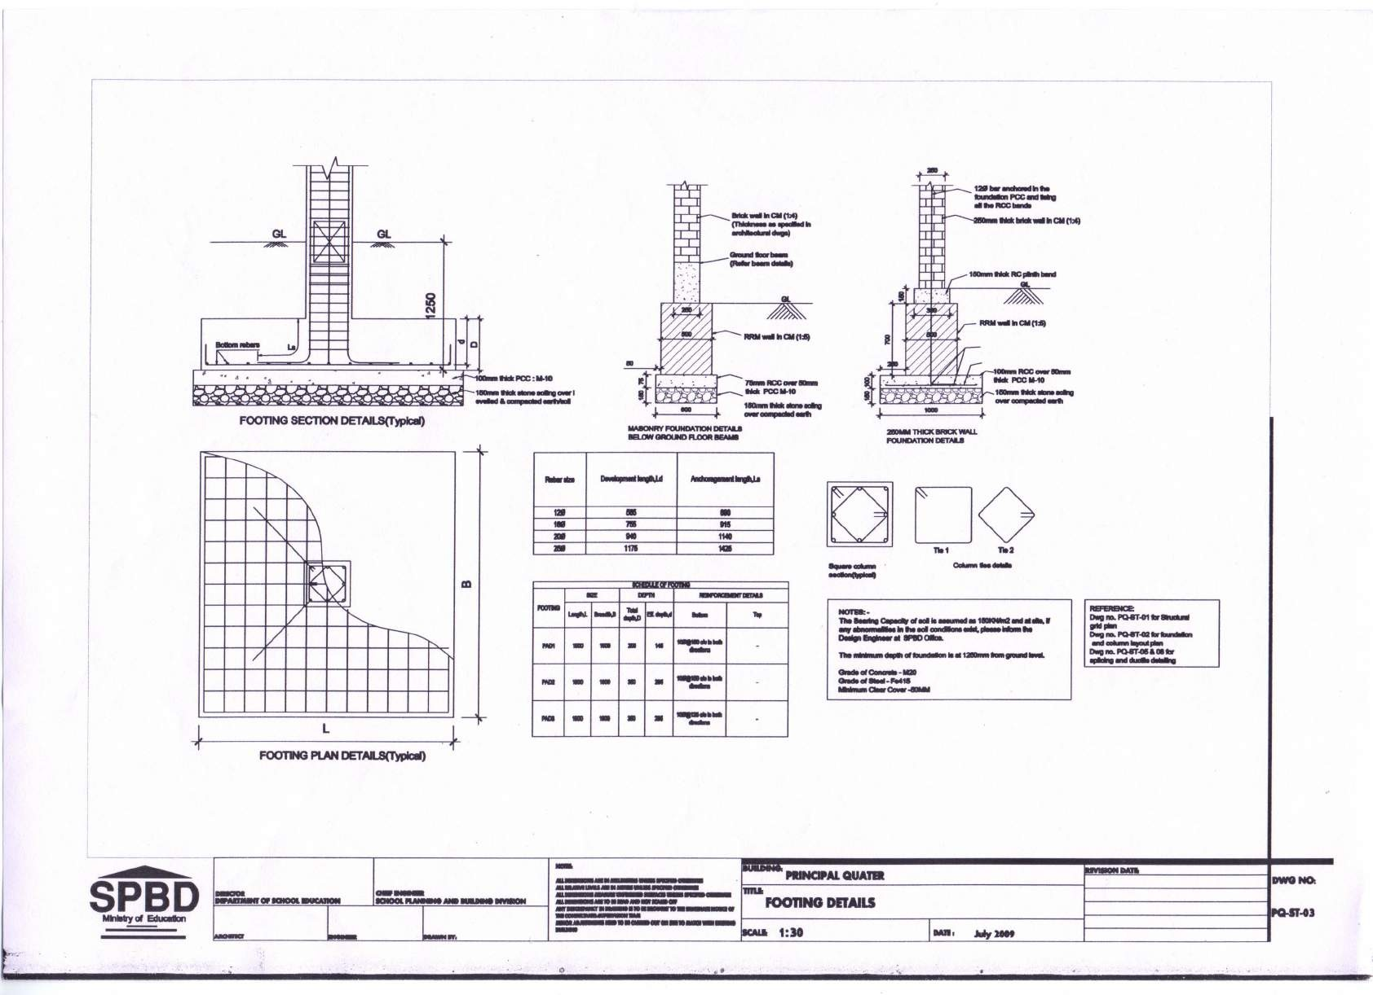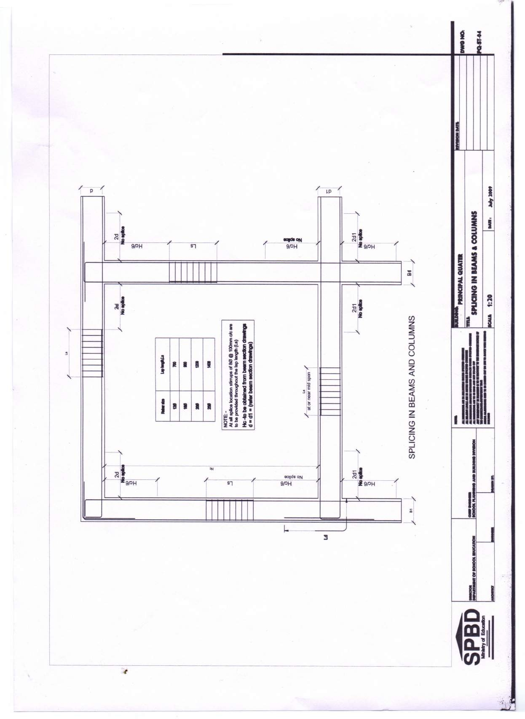

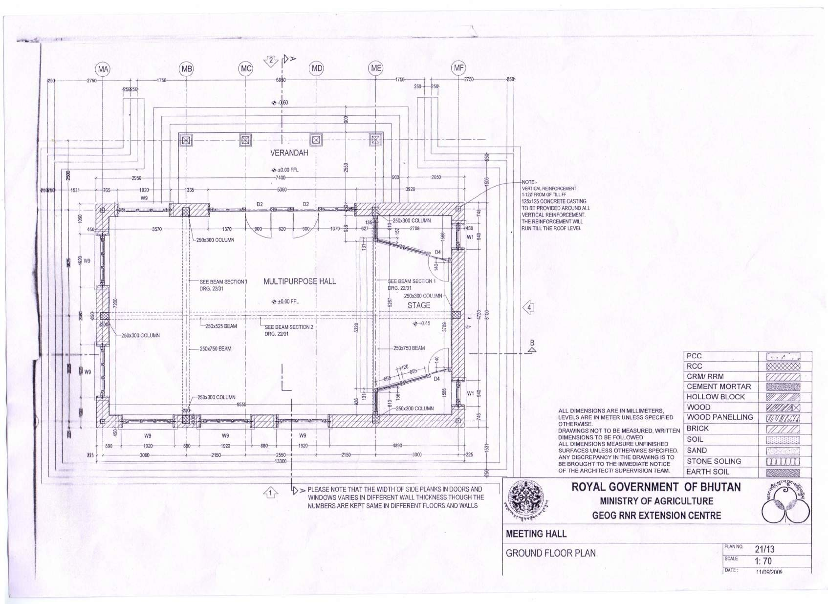

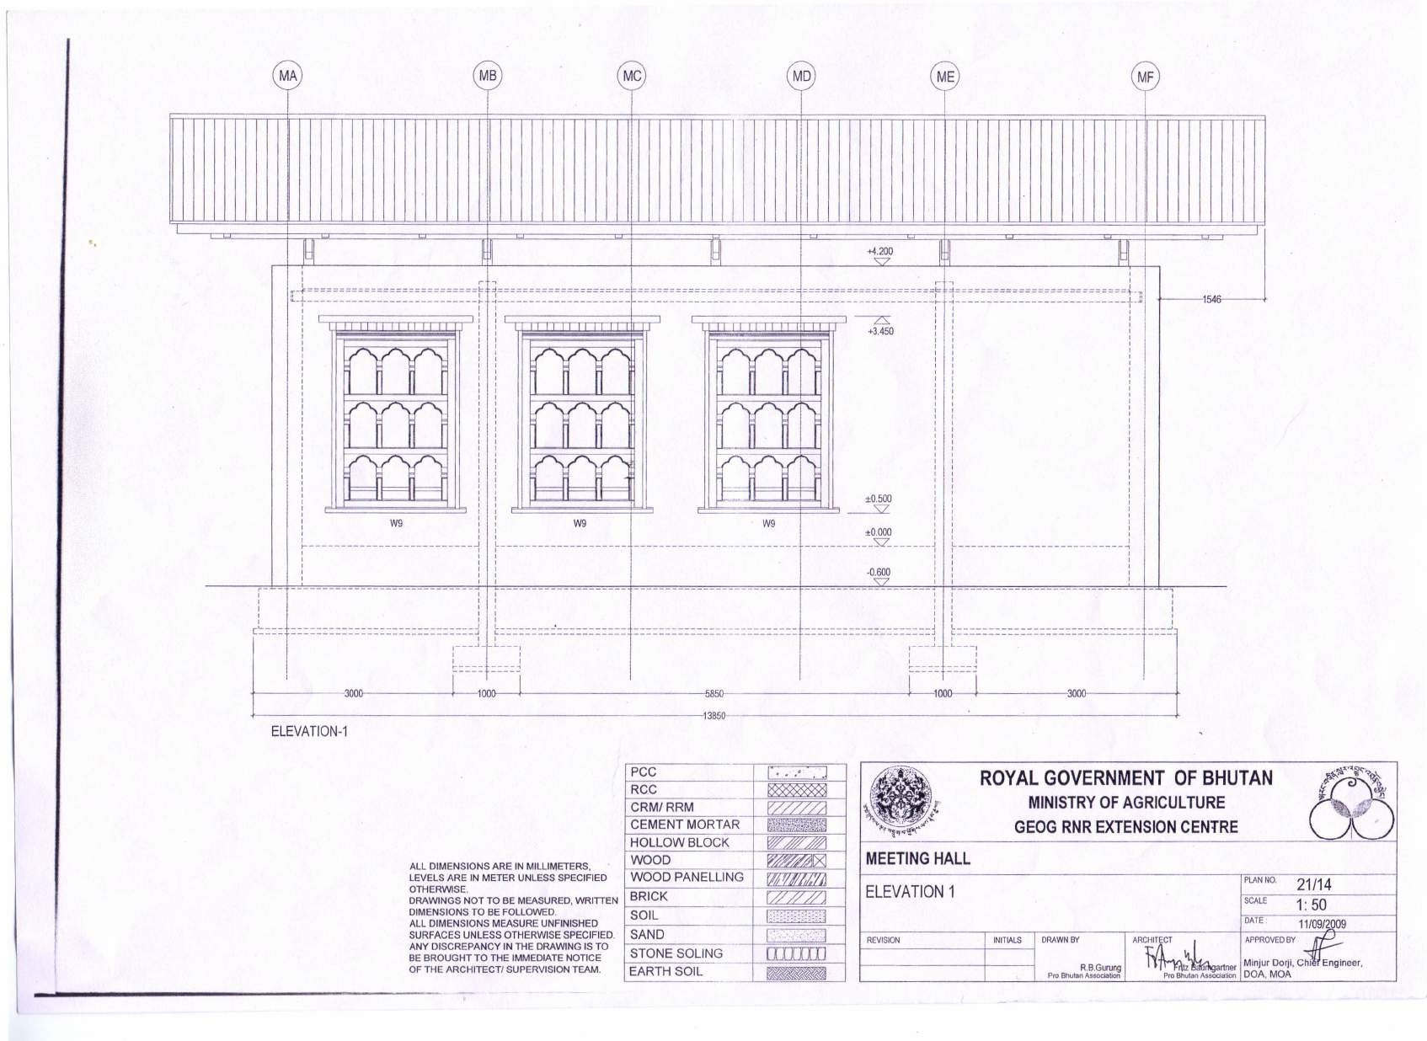

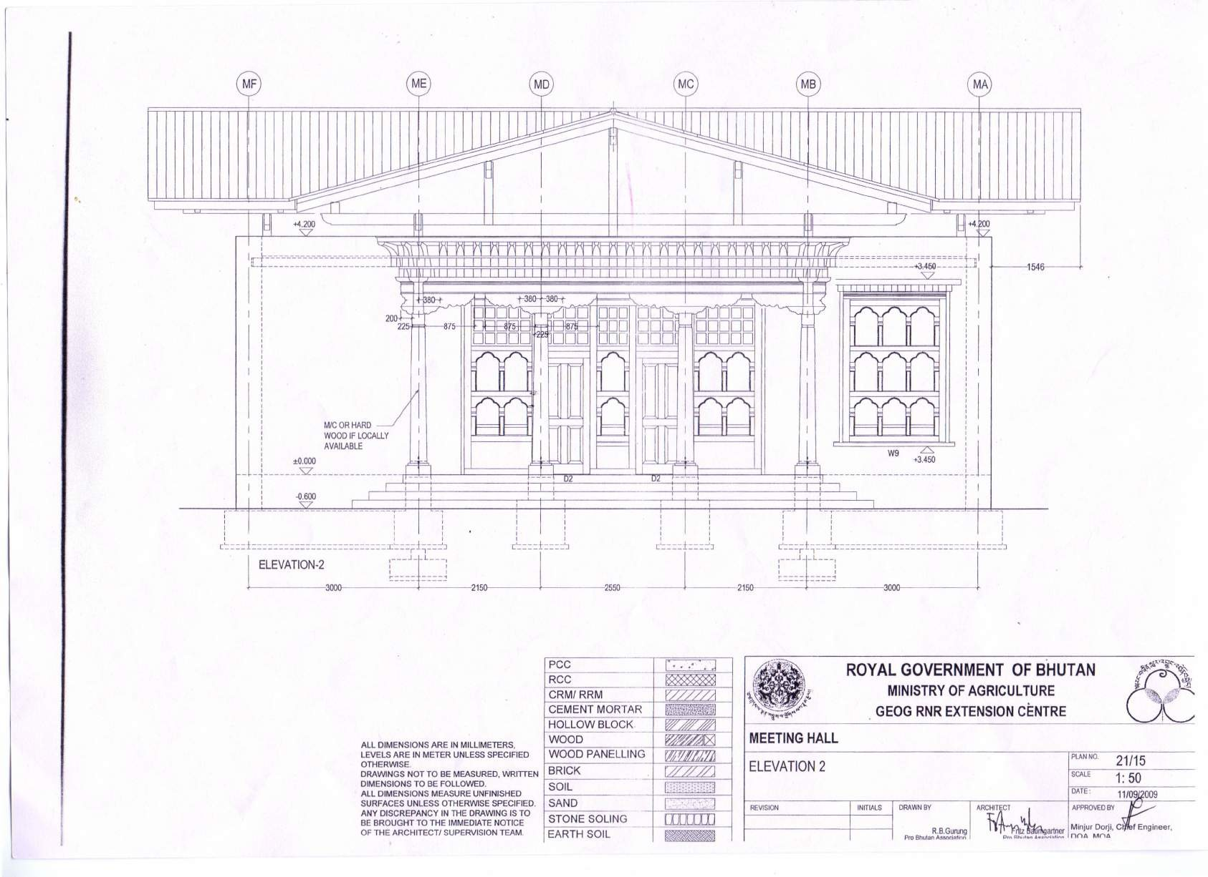

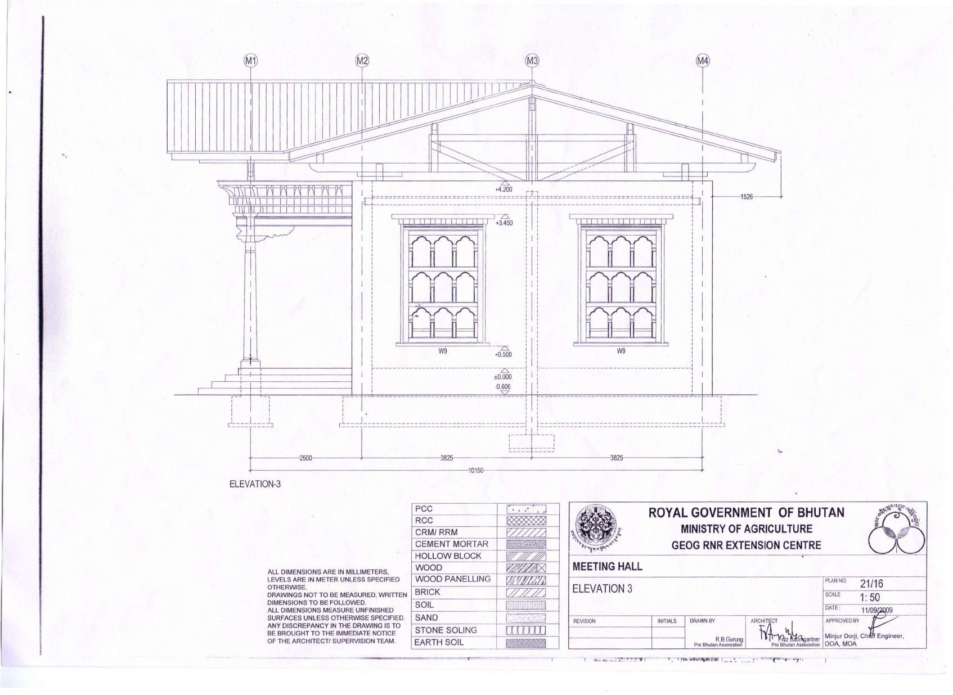

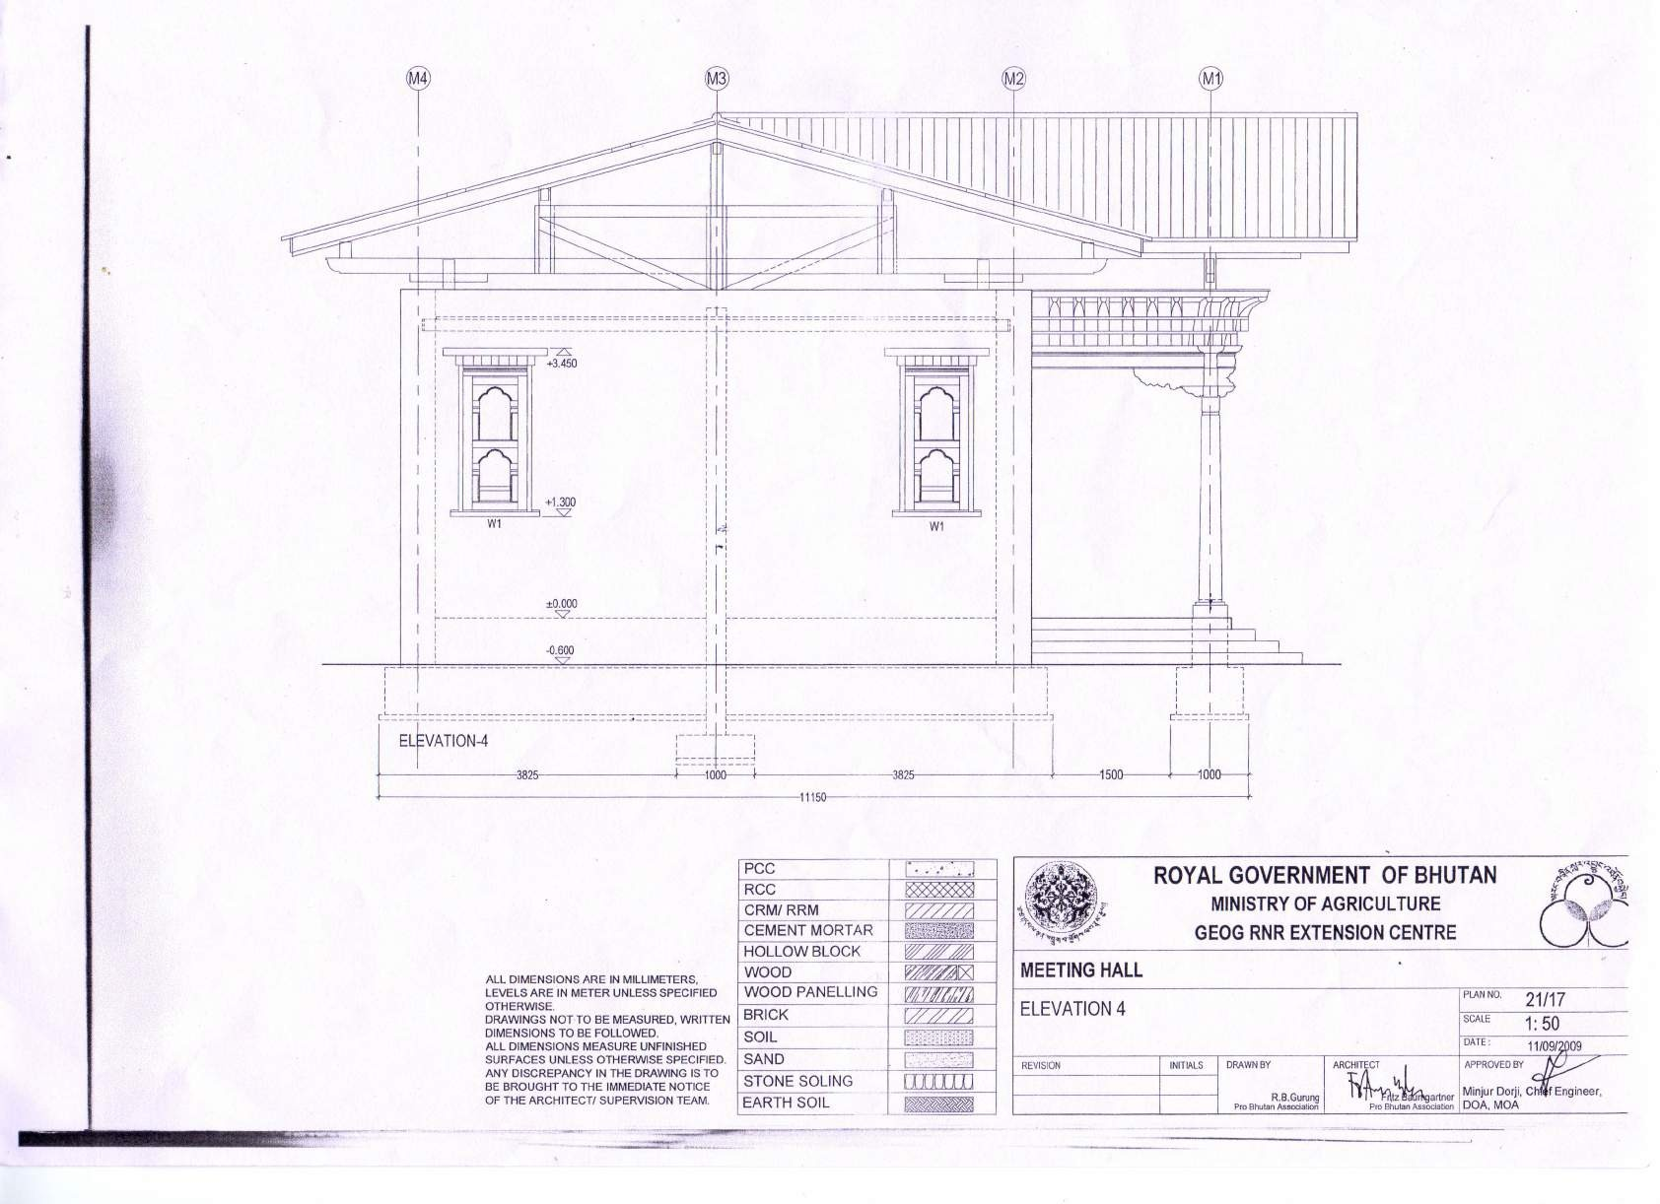

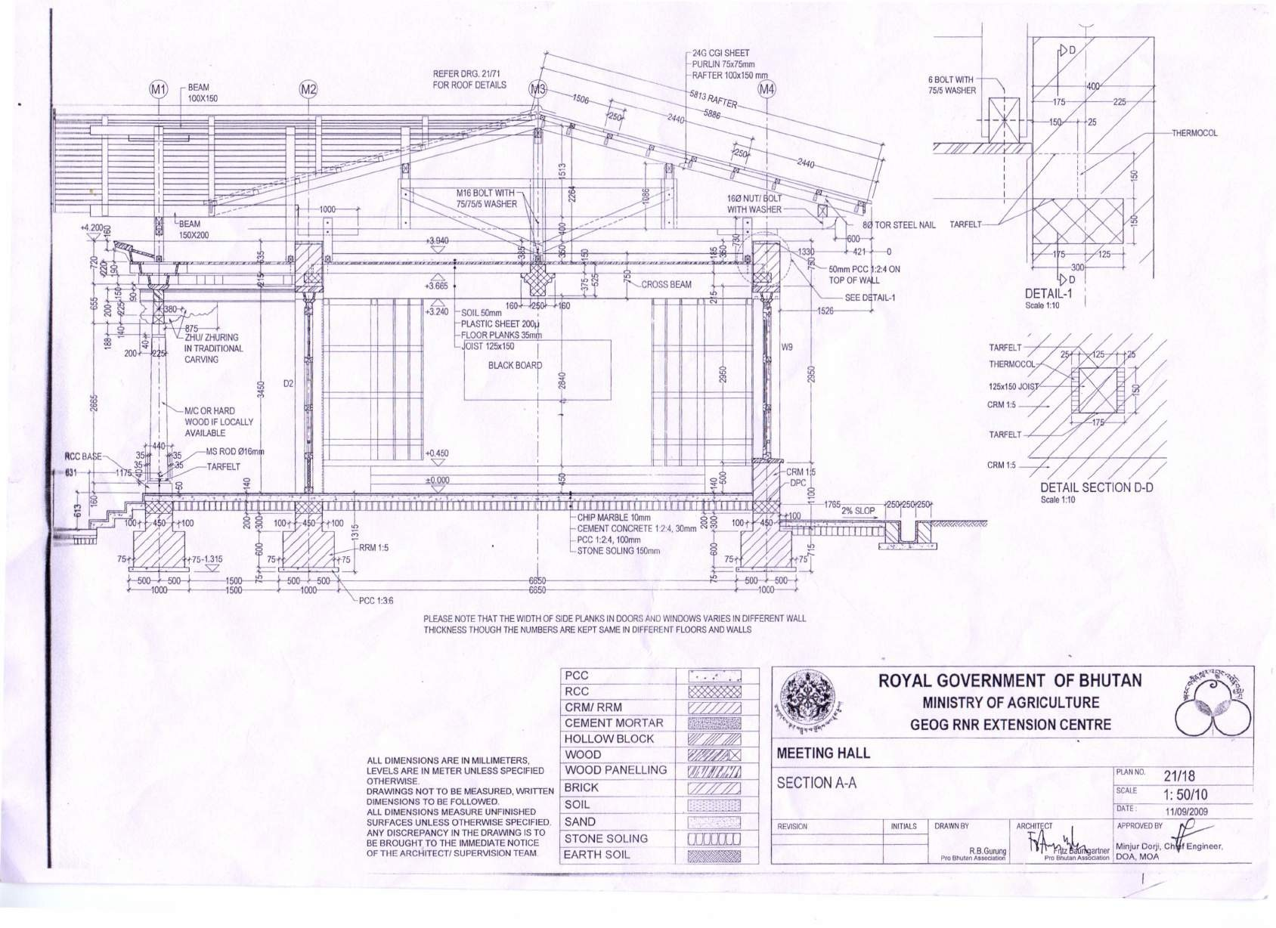

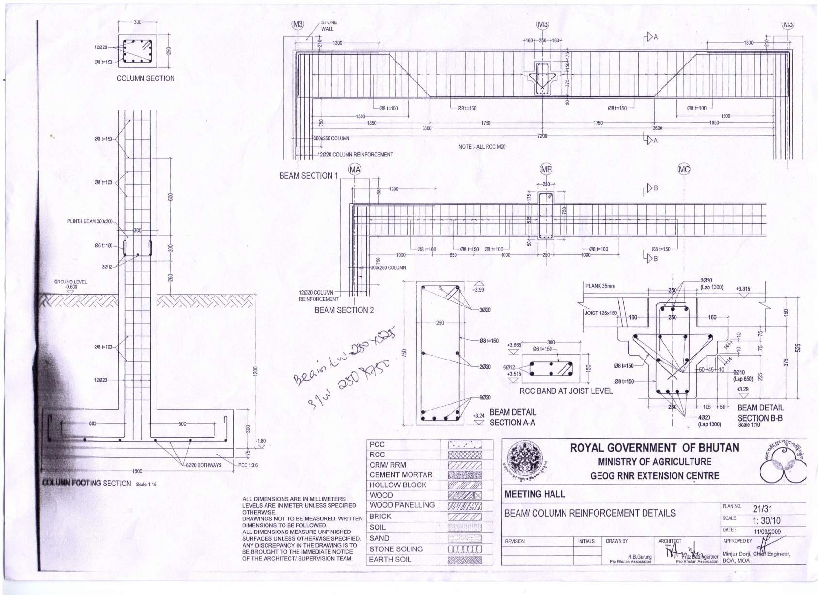

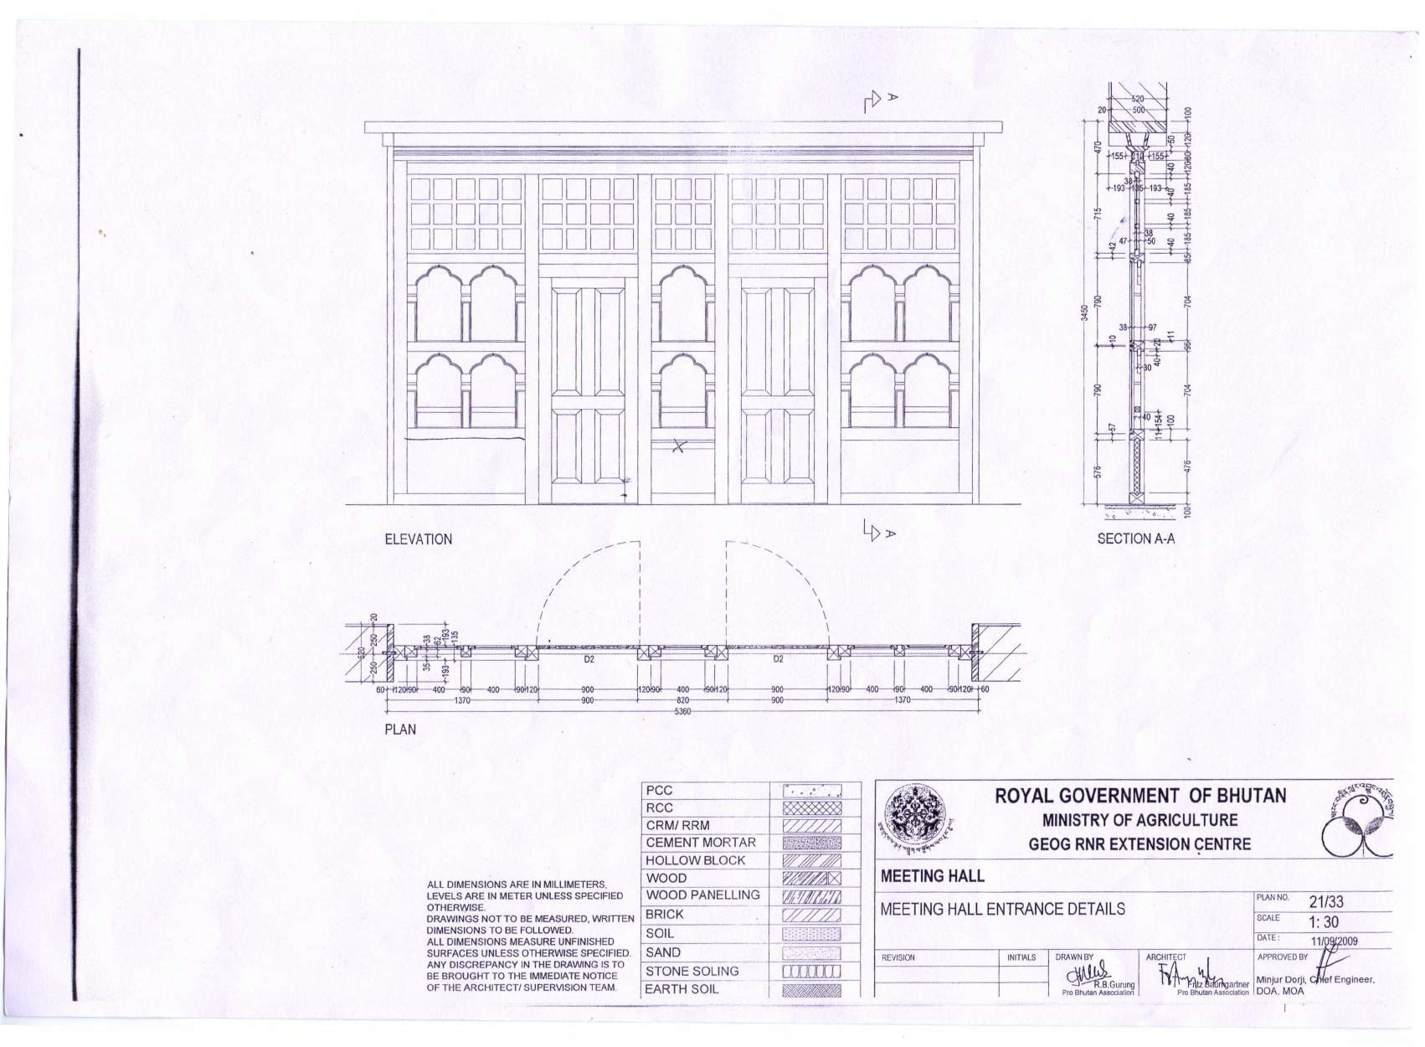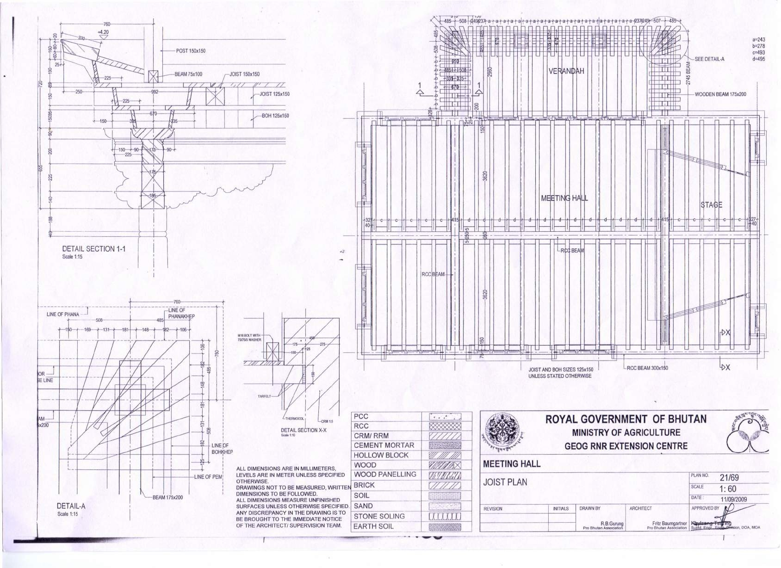

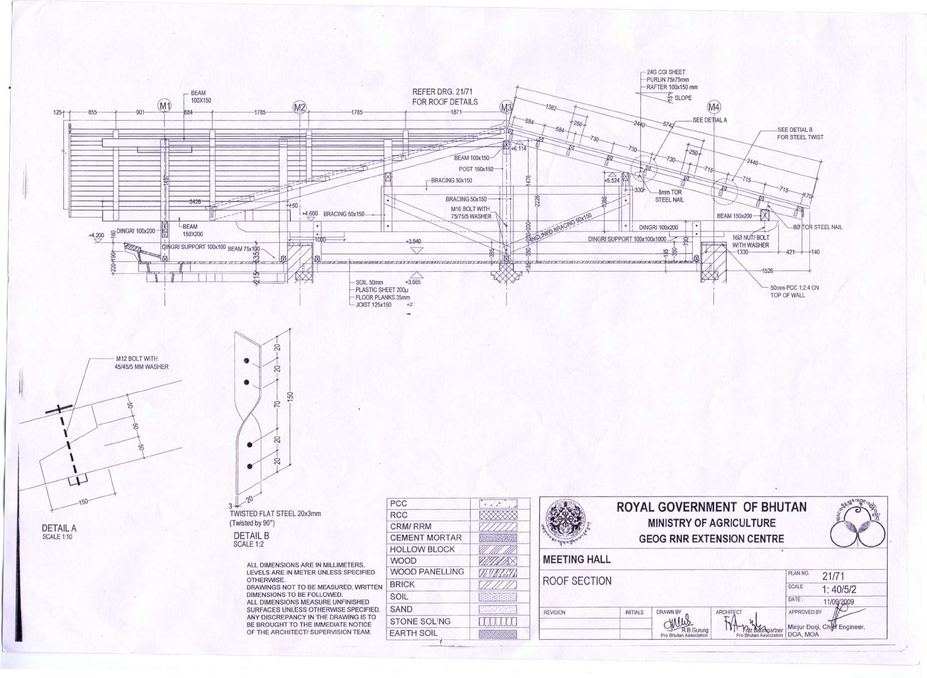

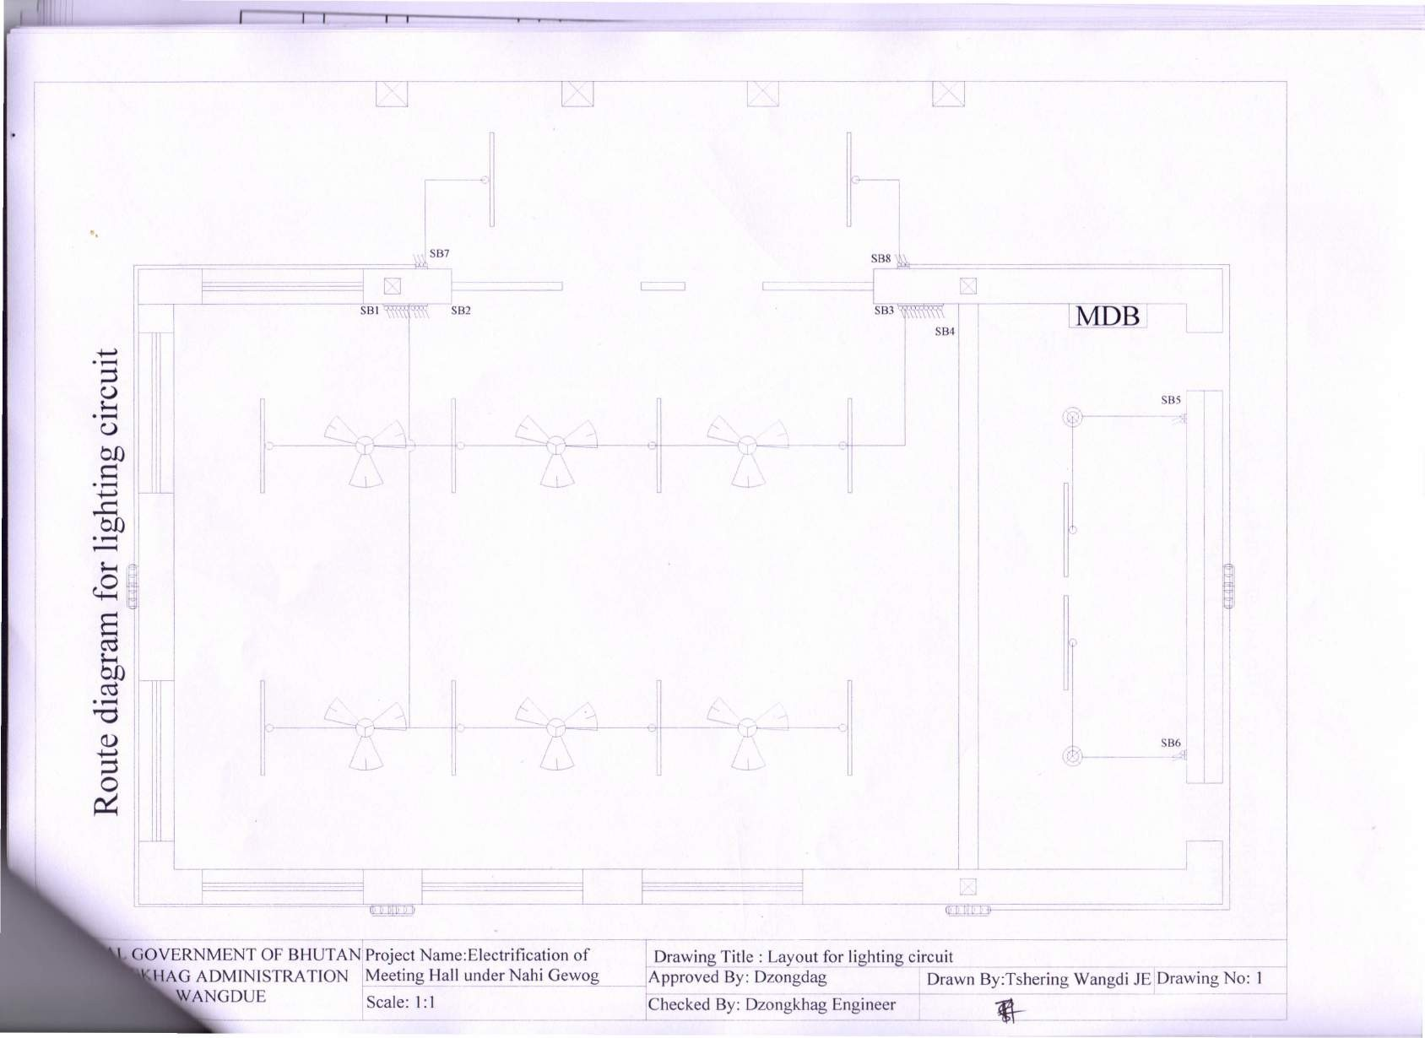

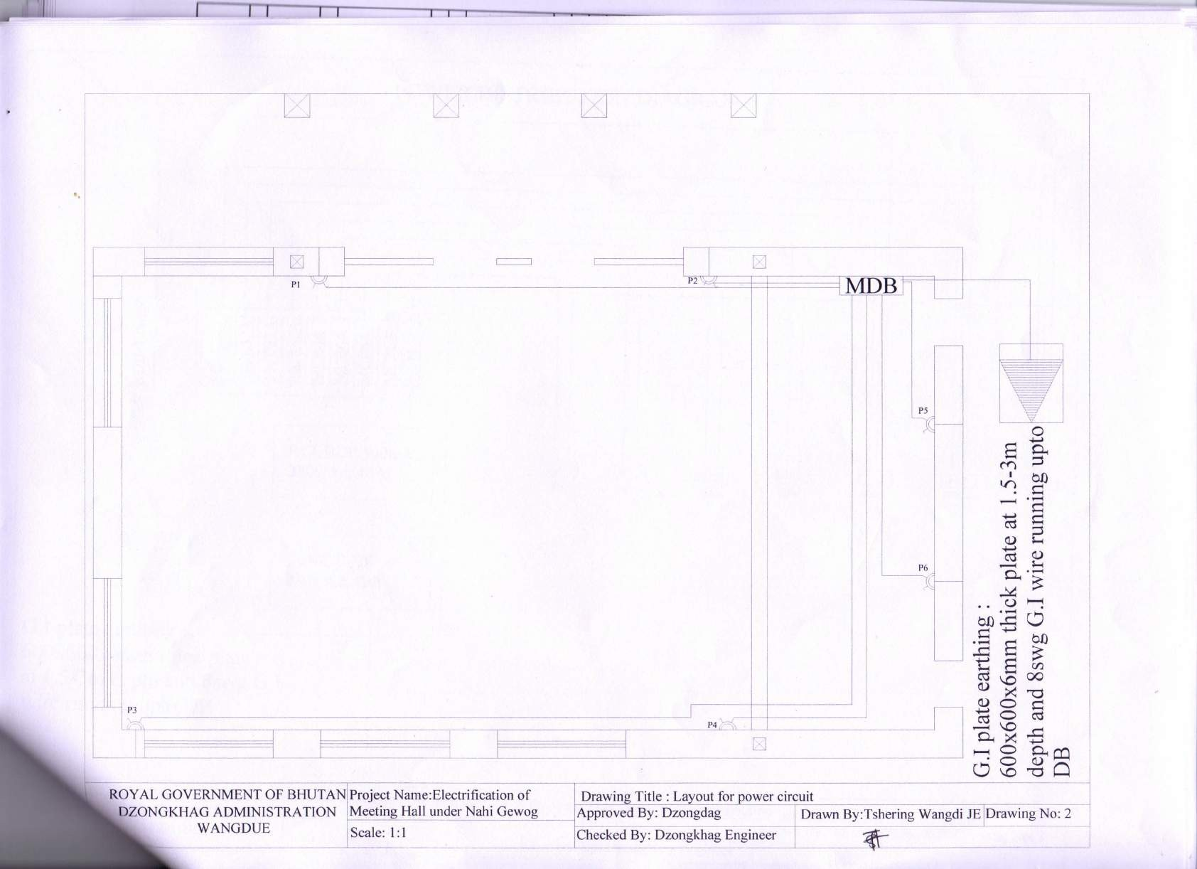

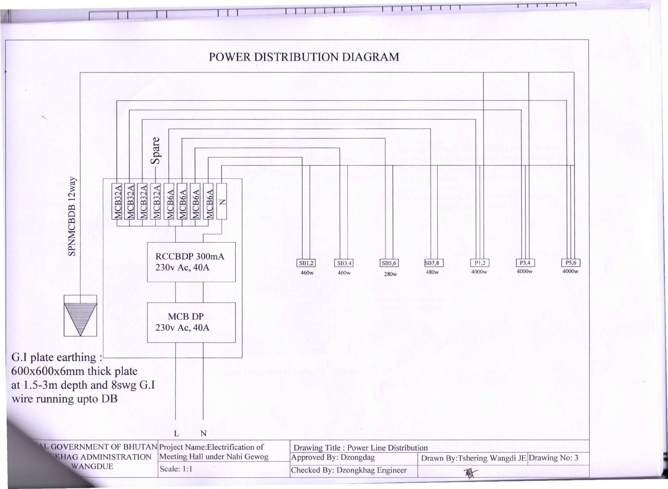

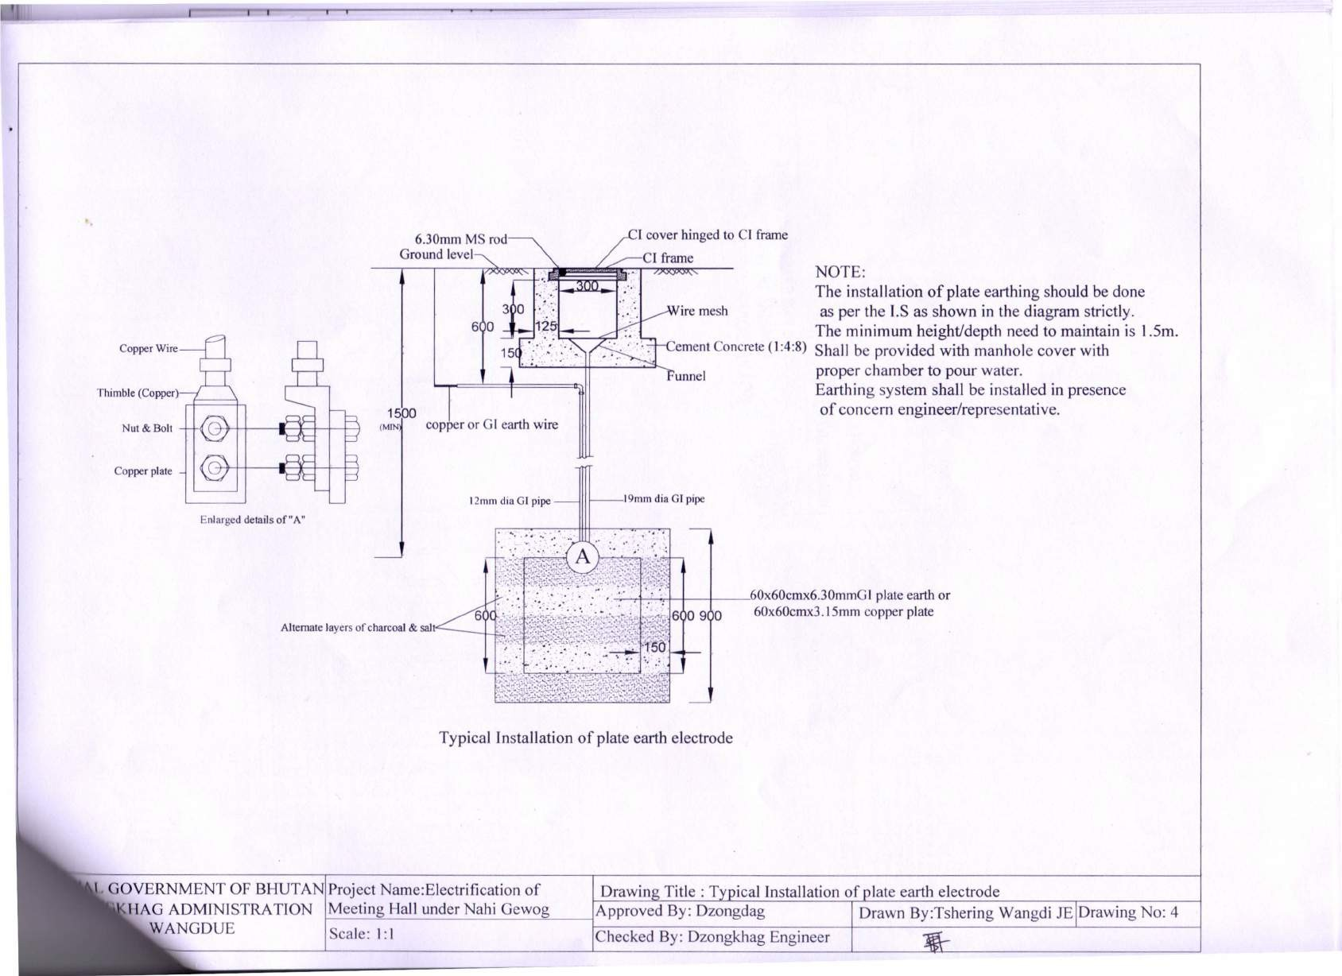

1. *‘Another party’ refers to a public official acting in relation to the procurement process or contract execution.*
2. *A ‘party’ refers to a public official; the term ‘benefit’ and ‘obligation’ relate to the procurement process or*

   *contract execution; and the ‘act or omission’ is intended to influence the procurement process or contract*

   *execution.*
3. *‘parties’ refers to participations in the procurement process including public officials attempting to establish bid prices at artificial, non competitive levels.*
4. *A ‘party’ refers to a participant in the procurement in the procurement process or contract execution.*
5. “another party” refers to a public official acting in relation to the procurement process or contract execution. In this context, “public official” includes staff and employees of any organizations (including any institutions providing finance for the Works) taking or reviewing procurement decisions.
6. “anything of value” includes, but is not limited to, any gift, loan, fee, commission, valuable security or other asset or interest in an asset; any office, employment or contract; any payment, discharge or liquidation of any loan, obligation or other liability whatsoever, whether in whole or in part; any other services, favour or advantage, including protection from any penalty or disability incurred or apprehended or from any action or proceeding of a disciplinary or penal nature, whether or not already instituted and including the exercise or the forbearance from the exercise of any right or any official power or duty.
7. a “party” refers to a public official; the terms “benefit” and “obligation” relate to the procurement process or contract execution; and the “act or omission” is intended to influence the procurement process or contract execution.
8. “parties” refers to participants in the procurement process (including public officials) and an “improper purpose” includes attempting to establish bid prices at artificial, non competitive levels.
9. a “party” refers to a participant in the procurement process or contract execution.